**ISO 19156:202X(X)**

ISO TC 211/WG 9

Secretariat: XXXX

**Geographic information** — Observations and measurements

CD stage

**Warning for WDs and CDs**

This document is not an ISO International Standard. It is distributed for review and comment. It is subject to change without notice and may not be referred to as an International Standard.

Recipients of this draft are invited to submit, with their comments, notification of any relevant patent rights of which they are aware and to provide supporting documentation.

© ISO 20XX

All rights reserved. Unless otherwise specified, or required in the context of its implementation, no part of this publication may be reproduced or utilized otherwise in any form or by any means, electronic or mechanical, including photocopying, or posting on the internet or an intranet, without prior written permission. Permission can be requested from either ISO at the address below or ISO’s member body in the country of the requester.

ISO copyright office

CP 401 • Ch. de Blandonnet 8

CH-1214 Vernier, Geneva

Phone: +41 22 749 01 11

Email: copyright@iso.org

Website: www.iso.org

Published in Switzerland

Contents

[Foreword v](#_Toc52382359)

[Introduction vi](#_Toc52382360)

[1 Scope 1](#_Toc52382361)

[2 Normative references 1](#_Toc52382362)

[3 Terms and definitions 2](#_Toc52382363)

[4 Document conventions 6](#_Toc52382364)

[4.1 Abbreviated terms and acronyms 6](#_Toc52382365)

[4.2 Schema language 6](#_Toc52382366)

[4.3 Model element names 6](#_Toc52382367)

[4.4 Requirements and recommendations 7](#_Toc52382368)

[4.5 Requirements classes 8](#_Toc52382369)

[4.6 Conformance classes 8](#_Toc52382370)

[4.7 Identifiers 9](#_Toc52382371)

[5 Packaging, requirements and dependencies 9](#_Toc52382372)

[5.1 Requirement and conformance class structure 9](#_Toc52382373)

[5.1.1 Requirements class dependency graphs 10](#_Toc52382374)

[5.2 UML package structure 11](#_Toc52382375)

[5.2.1 UML package dependencies 12](#_Toc52382376)

[5.3 Note of the use of Any 14](#_Toc52382377)

[6 Fundamental characteristics of observations and samples (informative) 15](#_Toc52382378)

[7 Conceptual Observation schema 15](#_Toc52382379)

[8 Abstract Observation Core 15](#_Toc52382380)

[9 Basic Observations 15](#_Toc52382381)

[10 Conceptual Sample schema 15](#_Toc52382382)

[11 Abstract Sample Core 15](#_Toc52382383)

[12 Basic Samples 15](#_Toc52382384)

[Annex A (normative) Abstract test suite 16](#_Toc52382385)

[A.1 Clause title autonumber 16](#_Toc52382386)

[A.1.1 Subclause autonumber 16](#_Toc52382387)

[A.1.1.1 Subclause autonumber 16](#_Toc52382388)

[Annex B (informative) Common usage of O&M terminology 18](#_Toc52382389)

[B.1 Clause title autonumber 18](#_Toc52382390)

[B.1.1 Subclause autonumber 18](#_Toc52382391)

[B.1.1.1 Subclause autonumber 18](#_Toc52382392)

[Annex C (informative) Alignment with ISO 19156:2011 19](#_Toc52382393)

[C.1 Clause title autonumber 19](#_Toc52382394)

[C.1.1 Subclause autonumber 19](#_Toc52382395)

[C.1.1.1 Subclause autonumber 19](#_Toc52382396)

[Annex D (informative) Best practices in use of the Observation and Sampling models 20](#_Toc52382397)

[D.1 Clause title autonumber 20](#_Toc52382398)

[D.1.1 Subclause autonumber 20](#_Toc52382399)

[D.1.1.1 Subclause autonumber 20](#_Toc52382400)

[Bibliography 21](#_Toc52382401)

Foreword

ISO (the International Organization for Standardization) is a worldwide federation of national standards bodies (ISO member bodies). The work of preparing International Standards is normally carried out through ISO technical committees. Each member body interested in a subject for which a technical committee has been established has the right to be represented on that committee. International organizations, governmental and non-governmental, in liaison with ISO, also take part in the work. ISO collaborates closely with the International Electrotechnical Commission (IEC) on all matters of electrotechnical standardization.

The procedures used to develop this document and those intended for its further maintenance are described in the ISO/IEC Directives, Part 1. In particular, the different approval criteria needed for the different types of ISO documents should be noted. This document was drafted in accordance with the editorial rules of the ISO/IEC Directives, Part 2 (see [www.iso.org/directives](https://www.iso.org/directives-and-policies.html)).

Attention is drawn to the possibility that some of the elements of this document may be the subject of patent rights. ISO shall not be held responsible for identifying any or all such patent rights. Details of any patent rights identified during the development of the document will be in the Introduction and/or on the ISO list of patent declarations received (see [www.iso.org/patents](https://www.iso.org/iso-standards-and-patents.html)).

Any trade name used in this document is information given for the convenience of users and does not constitute an endorsement.

For an explanation of the voluntary nature of standards, the meaning of ISO specific terms and expressions related to conformity assessment, as well as information about ISO's adherence to the World Trade Organization (WTO) principles in the Technical Barriers to Trade (TBT), see [www.iso.org/iso/foreword.html](https://www.iso.org/foreword-supplementary-information.html).

This document was prepared by Technical Committee ISO/TC 211, *Geographic information/Geomatics****,***  Working Group 9, *Information management*,  in collaboration with the Open Geospatial Consortium, Inc. (OGC).

This second edition cancels and replaces the first edition (ISO 19156:2011), which has been technically revised.

The main changes compared to the previous edition are as follows:

— xxx xxxxxxx xxx xxxx

Any feedback or questions on this document should be directed to the user’s national standards body. A complete listing of these bodies can be found at [www.iso.org/members.html](https://www.iso.org/members.html).

Introduction

This International Standard arises from work originally undertaken through the Open Geospatial Consortium’s Sensor Web Enablement (SWE) activity. A set of interfaces and protocols was standardized, through which applications and services are able to access sensors of all types, and observations generated by them, over the Web.

A new generation of geospatial standards is now emerging, based on general Web standards, architecture, and current practice, as described in <https://www.w3.org/TR/sdw-bp/>. This includes several new standards for describing and publishing sensors and observations, such as OGC SensorThings API and W3C/OGC Semantic Sensor Network Ontology. This new version of the Observations and Measurements Standard is informed by these recent developments and is aimed at enabling the publication of observation data as part of the Web of data, while also supporting other means of data exchange.

The content presented here derives from the previous version published by Open Geospatial Consortium as OGC 10-004r3, OGC Abstract Specification Geographic information — Observations and measurements (ISO 19156:2011). A technical note describing the changes from the earlier version is available from the Open Geospatial Consortium (see http://www.opengeospatial.org/standards/om).

Geographic information — Observations and measurements

# Scope

This International Standard defines a conceptual schema for observations, for features involved in the observation process, and for features involved in sampling when making observations. These provide models for the exchange of information describing observation acts and their results, both within and between different scientific and technical communities.

Observations commonly involve sampling of an ultimate feature-of-interest. This International Standard defines a common set of sample types according to their spatial, material (for ex-situ observations) or statistical nature. The schema includes relationships between sample features (sub-sampling, derived samples).

This International Standard concerns only externally visible interfaces and places no restriction on the underlying implementations other than what is needed to satisfy the interface specifications in the actual situation.

# Normative references

The following documents are referred to in the text in such a way that some or all of their content constitutes requirements of this document. For dated references, only the edition cited applies. For undated references, the latest edition of the referenced document (including any amendments) applies.

ISO 19101-1:2014, Geographic information — Reference model — Part 1: Fundamentals

ISO/TS 19101-2:2008, Geographic information — Reference model — Part 2: Imagery

ISO 19103:2015, Geographic information — Conceptual schema language

ISO 19107:2019, Geographic information — Spatial schema

ISO 19108:2002, Geographic information — Temporal schema

ISO 19109:2015, Geographic information — Rules for application schema

ISO 19111:2019, Geographic information — Referencing by coordinates

ISO 19115-1:2014, Geographic information — Metadata — Part 1: Fundamentals

ISO 19123-1:20xx, Geographic information — Schema for coverage geometry and functions — Part 1: Fundamentals[[1]](#footnote-1)

ISO 19123-2:2018, Geographic information — Schema for coverage geometry and functions — Part 2: Coverage implementation schema

ISO 19136-1:2020, Geographic information — Geography Markup Language (GML) — Part 1: Fundamentals

ISO 19136-2:2015, Geographic information — Geography Markup Language (GML) — Part 2: Extended schemas and encoding rules

ISO 19143:2010 Geographic information — Filter encoding

ISO 19157:2013, Geographic information — Data quality

ISO/IEC 19501:2005, Information technology — Open Distributed Processing — Unified Modeling Language (UML) Version 1.4.2

ISO Directives Part 2; [available at ISO/IEC Directives, Part 2: Rules for the structure and drafting of International Standards](https://www.iso.org/sites/directives/current/part2/index.xhtml)

# Terms and definitions

For the purposes of this document, the following terms and definitions apply.

ISO and IEC maintain terminological databases for use in standardization at the following addresses:

— ISO Online browsing platform: available at <https://www.iso.org/obp>

— IEC Electropedia: available at <http://www.electropedia.org/>

4.1

application schema

conceptual schema for data required by one or more applications

[ISO 19101-1:2014, definition 4.1.2]

4.2

coverage

feature that acts as a function to return values from its range for any direct position within its domain

[ISO 19123-1:20XX, definition 4.1.9]

4.3

data type

specification of a value domain with operations allowed on values in this domain

EXAMPLE Integer, Real, Boolean, String, Date.

NOTE Data types include primitive predefined types and user-definable types.

[ISO 19103:2015, definition 4.14]

4.4

domain

well-defined set

[ISO 19109:2015]

NOTE: All elements within a domain (set) are of a given type.

4.5

domain feature

feature of a type defined within a particular application domain

NOTE This may be contrasted with observation and sample features, which are features of types defined for cross-domain purposes.

4.6

ex-situ

referring to the study, maintenance or conservation of a specimen or population away from its natural surroundings (“off-site”)

NOTE Opposite of in-situ.

4.7

feature

abstraction of real-world phenomena

NOTE A feature may occur as a type or an instance. In this International Standard, feature instance is meant unless otherwise specified.

[ISO 19101-1:2014, definition 4.1.11]

4.8

feature type

class of features having common characteristics

4.9

measure

value described using a numeric amount with a scale or using a scalar reference system

[ISO 19136:2020, definition 3.1.41]

4.10

measurement

set of operations having the object of determining the value of a quantity

[ISO/TS 19101-2:2018, definition 3.21]

4.11

measurand

quantity intended to be measured

[VIM3: International vocabulary of metrology – Basic and general concepts and associated terms : BIPM/ISO 2012, definition 2.3]

4.12

property

facet or attribute of an object referenced by a name

[ISO 19143:2010, definition 4.21]

EXAMPLE Abby's car has the colour red, where "colour red" is a property of the car.

4.13

property type

characteristic of a feature type

EXAMPLE Cars (a feature type) all have a characteristic colour, where "colour" is a property type.

NOTE 1 The value for an instance of an observable property type can be estimated through an act of observation.

NOTE 2 In chemistry-related applications, the term "determinand" or "analyte" is often used.

NOTE 3 Adapted from ISO 19109:2005.

4.14

range

set of feature attribute values associated by a function, the coverage, with the elements of the domain of a coverage

NOTE This is consistent with the more generic definition of range in 19107 and 19136.

[ISO 19123-1:20XX, definition 4.1.44]

4.15

value

element of a type domain

[ISO/IEC 19501:2005]

NOTE 1 A value considers a possible state of an object within a class or type (domain).

NOTE 2 A data value is an instance of a datatype, a value without identity.

NOTE 3 A value can use one of a variety of scales including nominal, ordinal, ratio and interval, spatial and temporal. Primitive datatypes can be combined to form aggregate datatypes with aggregate values, including vectors, tensors and images.

4.16 : requirement

Expression, in the content of a document that conveys objectively verifiable criteria to be fulfilled and from which no deviation is permitted if conformance with the document is to be claimed

NOTE 1 Requirements are expressed using the verbal forms SHALL or SHALL NO. Equivalent phrases or expressions for use in certain cases are proposed by ISO.

[IS0/IEC Directives, Part 2 “Rules for the structure and drafting of International Standards”: 2018, definition 3.3.3]

4.17 : recommendation

Expression, in the content of a document, that conveys a suggested possible choice or course of action deemed to be particularly suitable without necessarily mentioning or excluding others

NOTE 1 Recommendations are expressed using the verbal forms SHOULD or SHOULD NOT. Equivalent phrases or expressions for use in certain cases are proposed by ISO.

NOTE 2 In the negative form, a recommendation is the expression that a suggested possible choice or course of action is not preferred but it is not prohibited.

[ISO/IEC Directives, Part 2 “Rules for the structure and drafting of International Standards”: 2018, definition 3.3.4]

# Conformance

## Overview

Clauses 7 to 13 of this International Standard use the Unified Modeling Language (UML) to present conceptual schemas for describing Observations. These schemas define conceptual classes that

a) may be considered to comprise a cross-domain application schema, or

b) may be used in application schemas, profiles and implementation specifications.

This flexibility is controlled by a set of UML types that can be implemented in a variety of manners. Use of alternative names that are more familiar in a particular application is acceptable, provided that there is a one-to-one mapping to classes and properties in this International Standard.

The UML model in this International Standard defines conceptual classes; various software systems define implementation classes or data structures. All of these reference the same information content. The same name may be used in implementations as in the model, so that types defined in the UML model may be used directly in application schemas.

Annex A defines a set of conformance tests that will support applications whose requirements range from the minimum necessary to define data structures to full object implementation.

## Conformance classes related to models including Observations and Measurements

The conformance rules for Models in general are described in ISO 19109:2015. Application Schemas also claiming conformance to this International Standard shall also conform to the rules specified in Clauses 7 to 13 and pass all relevant test cases of the Abstract Test Suite in Annex A.

Depending on the characteristics of an Application Schema, xx conformance classes are distinguished. Table x lists these classes and the corresponding subclause of the Abstract Test Suite.

|  |  |  |
| --- | --- | --- |
| **Conformance class** | **Identifier** | **Annex A clause** |
|  |  |  |
|  |  |  |
|  |  |  |
|  |  |  |
|  |  |  |
|  |  |  |
|  |  |  |
|  |  |  |
|  |  |  |
|  |  |  |
|  |  |  |
|  |  |  |
|  |  |  |
|  |  |  |
|  |  |  |
|  |  |  |
|  |  |  |
|  |  |  |
|  |  |  |

# Document conventions

## Abbreviated terms and acronyms

GFM General Feature Model

GML Geography Markup Language

INSPIRE INfrastructure for SPatial InfoRmation in Europe

O&M Observations and Measurements

OGC Open Geospatial Consortium

SensorML OGC Sensor Model Language

SOS OGC Sensor Observation Service

STA OGC SensorThings API

SWE OGC Sensor Web Enablement

UML Unified Modeling Language

XML Extensible Markup Language

2-D Two Dimensional

3-D Three Dimensional

## Schema language

The conceptual schema specified in this International Standard is in accordance with the Unified Modelling Language (UML) ISO/IEC 19501, following the guidance of ISO 19103:2015.

The UML in Abstract Core and Basic packages is conformant with the profile described in ISO 19136:2007, Annex E. Use of this restricted idiom supports direct transformation into a GML Application Schema. ISO 19136 introduces some additional stereotypes. In particular «FeatureType» implies that a class is an instance of the «metaclass» GF\_FeatureType (ISO 19109), and therefore represents a feature type.

The prose explanation of the model uses the term “property” to refer to both class attributes and association roles. This is consistent with the General Feature Model described in ISO 19109. In the context of properties, the term “value” refers to either a literal (for attributes whose type is simple), or to an instance of the class providing the type of the attribute or target of the association. Within the explanation, the property names (property types) are sometimes used as natural language words where this assists in constructing a readable text.

## Model element names

This International Standard specifies a model for observations using terminology that is based on current practice in a variety of scientific and technical disciplines. It is designed to apply across disciplines, so the best or "most neutral" term has been used in naming the classes, attributes and associations provided. The terminology does not, however, correspond precisely with any single discipline. As an aid to implementers, a mapping from the element names specified in this International Standard to common terminology in some application domains is provided in Annex B.

## Requirements and recommendations

All requirements are **normative**, and each is presented with the following template:

|  |  |
| --- | --- |
| **Requirement /req/{pkg}/{classM}/{reqN}** | [Normative statement] |

where **/req/{pkg}/{classM}/{reqN}** identifies the requirement. The use of this layout convention allows the normative provisions of this standard to be easily located by implementers. In the description of the convention right after the **/req/{pkg}/**part has been removed to ease reading.

All defined classes, attributes and associations mentioned within requirements or recommendations are shown in **bold** correspond to references to the definition of the referenced element.

The following base has been used per package:

* **/req/obs-cpt**: Conceptual Observation schema,
* **/req/obs-core**: Abstract Observation Core,
* **/req/obs-basic**: Basic Observations,
* **/req/sam-cpt**: Conceptual Sample schema,
* **/req/sam-core**: Abstract Sample core,
* **/req/sam-basic**: Basic Samples

For naming of individual requirements pertaining to classes, the following syntax is used:

* **{Class Name}-sem**: The semantic definition of the concept, together with the naming of the Class.

For naming of individual requirements pertaining to attribute or associations, the following syntax is used:

* **{Attribute/Association Name}-sem**: The semantic definition of the concept, together with the naming of the attribute or association role. Except for cases where concepts are mandatory within all packages, these statements are phrased to be cardinality neutral, e.g. they also apply to cardinality 0..\*;
* **{Attribute/Association Name}-type**: Type information pertaining to the attribute or association when the type is constrained within one model package;
* **{Attribute/Association Name}-card**: Cardinality information pertaining to the attribute or association;
* **{Attribute/Association Name}-con**: Additional constraints. As these sometimes pertain to multiple attributes or associations, this part of the name may become more complex.

All recommendations are **informative**, and each is presented with the following template:

|  |  |
| --- | --- |
| **Recommendation /rec/{pkg}/{classM}/{reqN}** | [Informative statement] |

where **/rec/{pkg}/{classM}/{reqN}** identifies the recommendation. The use of this layout convention allows the informative provisions of this standard to be easily located by implementers.

## Requirements classes

Each statement (requirement or recommendation) in this standard is a member of a requirements class.

All requirement classes are normative.

Each requirements class is described in a discrete clause, and summarized using the following template:

|  |  |
| --- | --- |
| **Requirements class** | **/req/{pkg}/{classM}** |
| Target type | [artefact or technology type] |
| Name | Name of the requirements class |
| Imports | /req/{pkg}/{classZ} |
| Requirement | /req/{pkg}/{classM}/{reqN} |
| Recommendation | /rec/{pkg}/{classM}/{recO} |
| Requirement | /req/{pkg}/{classM}/{reqP} |
| Requirement /Recommendation | [repeat as necessary] |

All requirements in a class must be satisfied. Hence, the requirements class is the unit of re-use and dependency.

Dependency to another requirement class (and the requirements and recommendations defined in it) is done using the “Imports” keyword. All requirements in a dependency SHALL also be satisfied by a conforming implementation.

A requirements class may consist only of dependencies and introduce no new requirements.

## Conformance classes

Conformance to this standard is possible at a number of levels, specified by conformance classes (Annex A). Each conformance class is summarized using the following template:

|  |  |
| --- | --- |
| **Conformance Class** | **/conf/{pkg}/{classM}** |
| Requirements | [identifier for the requirements class] |
| Test purpose | [Reason for test] |
| Test method | [Method to determine if test fulfilled] |
| Test Type | [Type of test] |

All tests in a class must be passed. Each conformance class tests conformance to a set of requirements packaged in a requirements class.

## Identifiers

Each requirements class, requirement and recommendation is identified by a unique identifier. This allows cross-referencing of class membership, dependencies, and links from each conformance test to the requirements tested. Appended to a base URI that identifies the specification as a whole, it enables the construction of a complete URI for identification in an external context.

The entire Requirements and Conformance Structure, consisting of the individual requirements and definitions together with the information on how these are linked together for the creation of Requirements and Conformance classes, will be exposed in a machine actionable format (such as the one provided by the OGC Definitions Server).

The URI for each requirements class has the form:

[base URI]**/req/{pkg}/{classM}**

The URI for each requirement has the form:

[base URI]**/req/{pkg}/{classM}/{reqN}**

The URI for each recommendation has the form:

[base URI]**/rec/{pkg}/{classM}/{reqN}**

The URI for each conformance class has the form:

[base URI]**/conf/{pkg}/{classM}**

# Packaging, requirements and dependencies

## Requirement and conformance class structure

As O&M implementations often seamlessly integrate with existing data ecosystems, a very flexible requirements and conformance structure is defined. It enables users to selectively mix and match elements as required for their purposes from the O&M data model without the necessity of achieving compliance with the entire data model.

Such flexibility is becoming increasingly relevant with the shift to Linked Data practices, where different organizations maintain and expose only certain aspects of a larger distributed dataset.

EXAMPLE A provider may only serve information on Observable Properties or Monitoring Facilities, while relying on other partners to provide information on measurement procedures. These could claim compliance to those parts falling under their responsibility, while letting other data providers link to these resources.

For this purpose, a fine grained structure for requirements and recommendations, requirements classes and conformance classes has been defined. As far as possible, patterns from the OGC Modular Specification (OGC 08-131r3) have been taken into account. However, pertaining to the alignment between UML Packages and Conformance Classes, a relaxation of the requirement on one-to-one alignment between UML Package and Conformance Class has been proposed as follows:

* For each UML Package, both a Requirements Class as well as a Conformance Class have been defined;
* Additional Requirements Classes have been created for each Class appearing in the data model, Conformance Classes are added accordingly to enable grouping of the formers and support references to either a group or an individual Requirement Class depending on the need;
* Thematic Domains may create additional Requirements and Conformance Classes reflecting their domain profiles by reference to existing Requirements and Requirements Classes.

As mentioned, as data provision paradigms increasingly shift towards distributed and linked approaches, it becomes increasingly difficult to stipulate that all aspects of an information system conform explicitly to the same underlying standards. Simultaneously, as distributed data provision becomes increasingly ubiquitous, ever more communities are emerging dedicated to individual aspects of the wider data provision landscape.

One example of such external definition and hosting pertains to the provision of observable properties. In previous versions of the O&M Model, this concept was only included as a metaclass, with the assumption that a reference to an existing code list will be provided. Within the current O&M Model, the observable property has been upgraded to a featureType, as emerging requirements show the need for a more detailed model for this concept. Simultaneously, other communities such as the Research Data Alliance (RDA) are also working on observable property models. The same rationale can be applied to most concepts from the O&M Models.

In order to expose this flexibility beyond the package structure described above, a fine grained hierarchical requirements class structure has been created. A modular requirements class is provided for each concept at all three levels of the model. In addition, a further requirements class that imports all the modular classes provided for the individual concepts has been provided for each package.

### Requirements class dependency graphs

The graphs in **Figure 5.1** and **Figure 5.2** have been auto-generated by parsing the requirements class tables contained in this document, and are provided here for the reader convenience.

Double-bordered boxes are requirements classes, simple boxes are individual requirements or recommendations. Arrows with solid lines show inclusion of requirements, dotted lines are dependencies showing where other requirement classes have been imported.

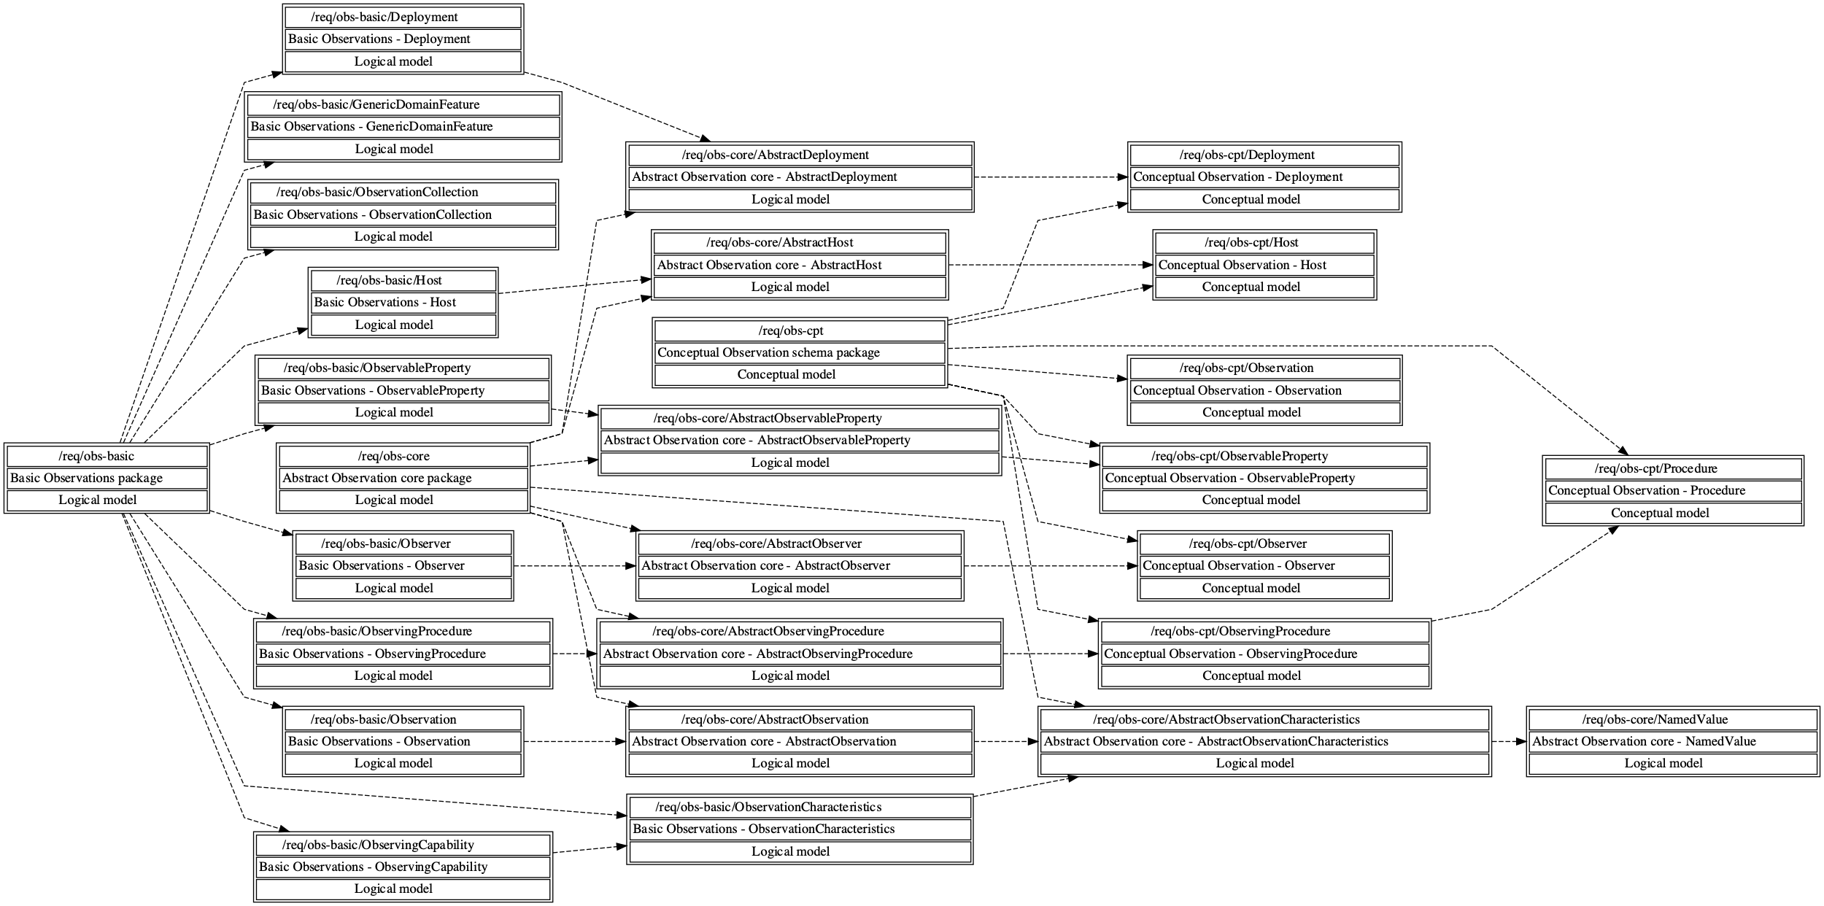

**Figure 6.1 — Requirements class dependencies of the Observation packages.**

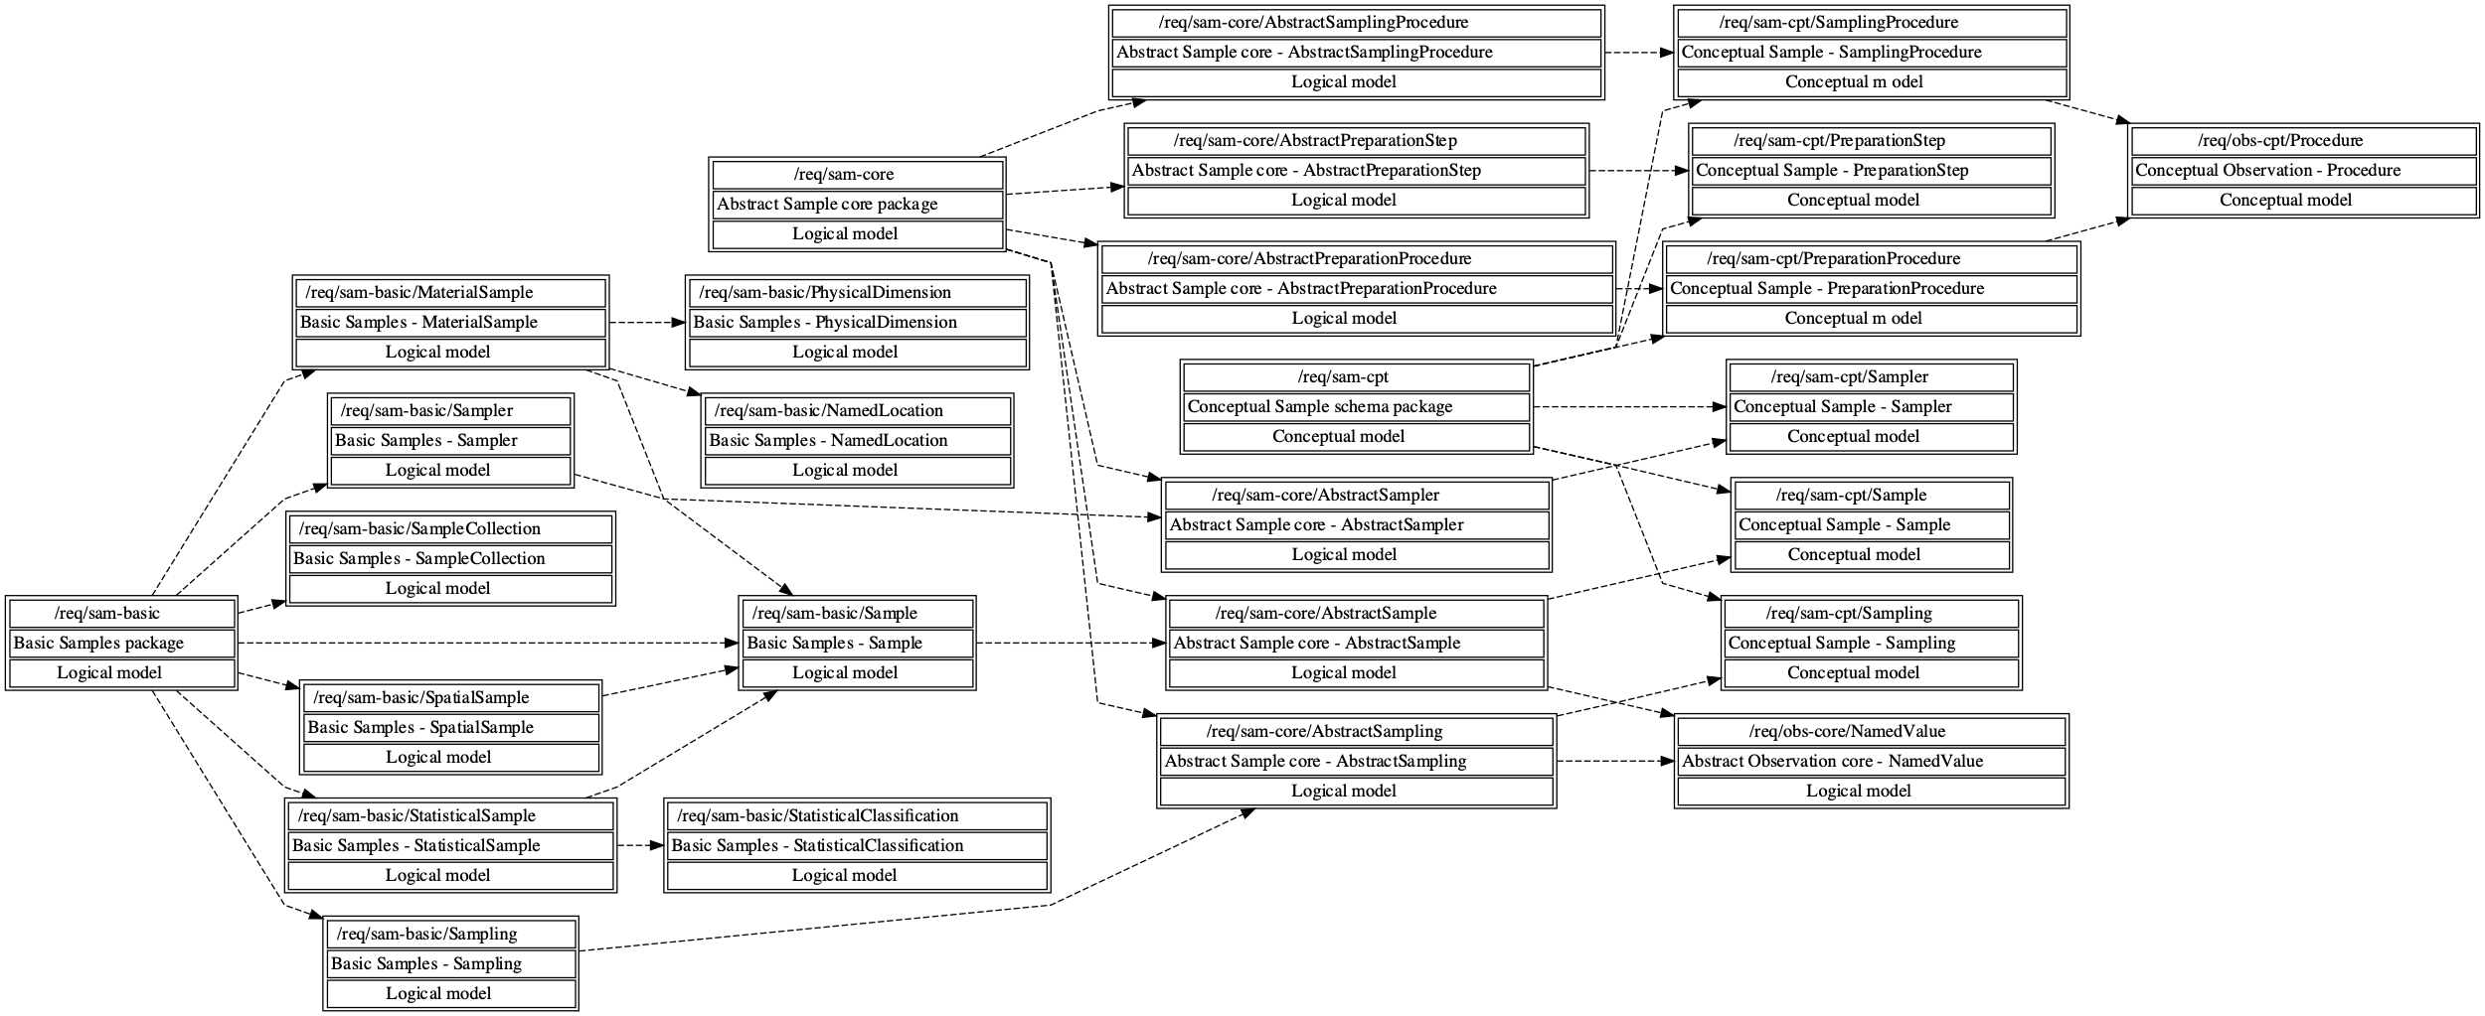

**Figure 6.2 — Requirement class dependencies of the Sample packages.**

## UML package structure

O&M provides the relevant concepts for the structured description of observations, including the sampling structure often essential for true understanding of the nature of the observations being provided. As data provision mechanisms are transitioning towards highly distributed linked approaches, the model structure and packaging has been significantly abstracted. This approach allows implementers to explicitly select the concepts to be supported based on their requirements, while clearly stating to which requirements and Conformance Classes their implementation complies. Both the Observation and Sample sections of this model have been structured using the following layering of packages:

* **Conceptual**: Within the Conceptual Model Packages, only Interfaces have been provided. These models provide a very abstract view on the individual concepts they contain without reference to specific implementations. This approach allows for the inclusion of semantically aligned objects from external sources, that while not having been created under the Observations & Measurements Model do provide concepts sharing the same semantic meaning as the concepts from the Conceptual Models;
* **Abstract Core**: Within the Abstract Core Model Packages, only abstract featureTypes have been provided following the semantic structure of the Conceptual model (i.e: realizing the interfaces provided by the Conceptual). A consistent approach to metadata provision introduced. All associations from the abstract featureTypes reference the conceptual Interfaces for greater flexibility of implementation. The Abstract Core Model Packages are foreseen for the creation of domain models providing an Abstract Core ready for Extension;
* **Basic**: Within the Basic Packages, simple concrete featureTypes (specializing the abstract ones from the Abstract Core model) have been defined with some basic utility attributes added for rapid out-of-the-box deployment. A few additional concepts pertaining to collections and potential observations are introduced at this level.

### UML package dependencies

Some model elements used in the schema are defined in other International Standards. The **Table 5.1** lists the dependencies between the UML packages defined in this International Standard and other International Standards, and the **Figure 5.3** show the dependencies of the entire Observations and measurements UML model package to the other International Standards in a graphical form.

**Table 5.1 — UML package level dependencies**

|  |  |  |  |
| --- | --- | --- | --- |
| **Dependency from package** | **to package** | **in an International Standard** | **Notes** |
| Conceptual Observation schema | Any type | ISO 19103:2015 (Edition 1) | Any |
| Conceptual Observation schema | Temporal Objects | ISO 19108:2002 (Edition 1) | TM\_Object |
| Conceptual Observation schema | Name types | ISO 19103:2015 (Edition 1) | GenericName |
| Abstract Observation core | Conceptual Observation schema | This International Standard | TM\_Instant, TM\_Period via the Temporal Objects dependency |
| Abstract Observation core | General Feature Model | ISO 19109:2015 (Edition 2) | Feature concepts |
| Abstract Observation core | Text | ISO 19103:2015 (Edition 1) | CharacterString |
| Basic Observations | Abstract Observation core | This International Standard |  |
| Basic Observations | Web environment | ISO 19103:2015 (Edition 1) | URI |
| Basic Observations | Geometry | ISO 19107:2019 (Edition 2) | Geometry |
| Conceptual Sample schema | Any type | ISO 19103:2015 (Edition 1) | Any |
| Conceptual Sample schema | Temporal Objects | ISO 19108:2002 (Edition 1) | TM\_Object |
| Conceptual Sample schema | Name types | ISO 19103:2015 (Edition 1) | GenericName |
| Conceptual Sample schema | Conceptual Observation schema | This International Standard | Observation, Procedure |
| Abstract Sample core | Conceptual Sample schema | This International Standard |  |
| Abstract Sample core | General Feature Model | ISO 19109:2015 (Edition 2) | Feature concepts |
| Abstract Sample core | Geometry | ISO 19107:2019 (Edition 2) | Geometry |
| Abstract Sample core | Text | ISO 19103:2015 (Edition 1) | CharacterString |
| Abstract Sample core | Abstract Observation core | This International Standard | NamedValue |
| Basic Samples | Abstract Sample core | This International Standard |  |
| Basic Samples | Web environment | ISO 19103:2015 (Edition 1) | URI |
| Basic Samples | Measure types | ISO 19103:2015 (Edition 1) | Measure |

**Figure 6.3 - External UML package dependencies**

## Note of the use of Any

The UML models defined in this International Standard make extensive use of the Any interface defined in ISO 19103:2015 Any type package. The realized Any values of the associations with role names **proximateFeatureOfInterest**, **ultimateFeatureOfInterest**, **result**, **metadata**, **featureOfInterest** and **sampledFeature** MAY be of any type or a reference to an digital representation of an appropriate concept. In the case they are of feature type, the values are not owned by the instances of referring classes, they may have an independent life span from the referring classes, and they may be associated with more than one instance of referring classes.

NOTE any type can be owl:Thing, featureType, dataType

EXAMPLES:

* Reference to SWEET Ontology: http://sweetontology.net/realmAtmoBoundaryLayer#planetaryboundarylayer
* Reference to SensorThings deployment: <https://lubw-frost.docker01.ilt-dmz.iosb.fraunhofer.de/v1.1/Locations(269)>
* Reference to 19115 Metadata: <https://inspire-geoportal.ec.europa.eu/resources/INSPIRE-61494ff5-6fad-11e8-b649-52540023a883_20200903-065202/services/1/PullResults/601-650/31.iso19139.xml>
* Reference to an instance of Borehole : <https://data.geoscience.fr/id/borehole/BSS001REWW>
* Reference to an hydro station : <https://iddata.eaufrance.fr/id/HydroStation/Y251002001>
* Reference to a river segment : <https://iddata.eaufrance.fr/id/WatercourseLinkSequence/A0080300>
* An (embedded) Boolean value as Result
* An (embedded) SWE DataRecord
* Elevation Coverage from an external WCS as an observation Result: <https://inspire.rasdaman.org/rasdaman/ows?service=WCS&version=2.0.1&request=GetCoverage&coverageId=INSPIRE_EL&subset=E(494500,496000)&subset=N(4654300,4655000)&format=image/jpeg>
* O&M MaterialSample -> Reference to a rock sample : <https://www.geodata.rocks/Samples/SD-5054_1_A_564_7WR_20-40>

# Fundamental characteristics of observations and samples (informative)

## Observation schema

### Property evaluation

Properties of a feature fall into two basic categories:

1. Value (e.g. name, price, legal boundary) assigned by some authority. These are exact.
2. Value (e.g. height, classification, colour) determined by application of an observation procedure.

These are estimates, with a finite error associated with the value.

The observation error typically has a systematic component, which is similar for all estimates made using the same procedure, and a random component, associated with the particular application instance of the observation procedure. If potential errors in a property value are important in the context of a data analysis or processing application, then the details of the act of observation which provided the estimate of the value are required.

### Observation

An observation is an act associated with a discrete time instant or period through which a number, term or other symbol is assigned to a phenomenon [2]. It involves application of a specified procedure, such as a sensor, instrument, algorithm or process chain. The procedure may be applied in-situ, remotely, or ex-situ with respect to the sampling location. The result of an observation is an estimate of the value of a property of some feature. Use of a common model allows observation data using different procedures to be combined unambiguously.

In conventional measurement theory (e.g. [1][5][10][11][20]) the term “measurement” is used. However, a distinction between measurement and category-observation has been adopted in more recent work [2][12][21] so the term “observation” is used here for the general concept. “Measurement” may be reserved for cases where the result is a numerical quantity.

The observation itself is also a feature, since it has properties and identity.

Observation details are important for data discovery and for data quality estimation.

The observation could be considered to carry “property-level” instance metadata, which complements the dataset-level and feature-level metadata that have been conventionally considered (e.g. ISO 19115 or other community agreed one).

### Properties of an Observation

An observation results in a value being assigned to a phenomenon. The phenomenon is a property of a feature, the latter being the feature-of-interest of the observation. The observation uses a specified procedure performed by an observer, which is often an instrument or sensor [1][2], but may be a process chain, human observer, an algorithm, a computation or simulator. The key idea is that the observation result is an estimate of the value of some property of the feature-of-interest, and the other properties of the observation properties of the observation provide context or metadata to support evaluation, interpretation and use of the result.

The relationship between the properties of an observation and those of its feature-of-interest is key to the semantics of the model. This is further elaborated in Annex D.3.

### Observation location

The principal location of interest is usually associated with the ultimate feature-of-interest.

However, the location of the feature-of-interest may not be trivially available. For example: in remote sensing applications, a complex processing chain is required to geolocate the scene or swath; in feature-detection applications the initial observation may be made on a scene, but the entity to be detected, which is the ultimate feature-of-interest, occupies some location within it. The distinction between the proximate and ultimate feature-of-interest is a key consideration in these cases.

Other locations appear in various scenarios. Sub-sampling at locations within the feature-of-interest may occur. The procedure may involve a sensor located remotely from the ultimate feature-of-interest like in remote sensing, or where specimens are removed from their sampling location and observations made ex-situ (the sampling schema description below elaborates on this). Furthermore, the location of the feature-of-interest may be time-dependent.

The model is generic. The geospatial location of the feature-of-interest may be of little or no interest for some observations (e.g. live specimens, observations made on non-located things like chemical species).

For these reasons, a generic Observation class does not have an inherent location property. Relevant location information should be provided by the feature-of-interest, by the sampling procedure, or by the observation procedure, according to the specific scenario.

NOTE In contrast to spatial properties, some temporal properties are associated directly with an observation (7.2.2.2; 7.2.2.3). This is a consequence of the fact that an observation is a kind of ‘event’ so its temporal characteristics are fundamental, rather than incidental.

### Result types

Observation results may have many datatypes, including primitive types like category or measure, but also more complex types such as time, location and geometry. Complex results are obtained when the observed property requires multiple components for its encoding. Furthermore, if the property varies on the feature-of-interest, then the result is a coverage, whose domain extent is the extent of the feature. In a physical realization, the result will typically be sampled discreetly on the domain, and may be represented as a discrete coverage.

Building on this, Specialized observation types as defined by communities help describe the type of result provided.

### Use of the observation model

The Observation model takes a data-user-centric viewpoint, emphasizing the semantics of the feature-of-interest and its properties. This contrasts with Sensor-oriented models, which take a process- and thus provider-centric viewpoint.

An observation is a property-value-provider for a feature-of-interest. Aside from the result, the details of the observation event are primarily of interest in applications where an evaluation of errors in the estimate of the value of a property is of concern. The Observation could be considered to carry “property-level” instance metadata, complementing the dataset-level and feature-level metadata that have been conventionally considered (e.g. ISO 19115).

Additional discussion of the application of the observation and sample models, and nuances within these, is provided in Annex C.

## Sample schema

### Role of sample features

A Sample may act as a proxy for the ultimate feature-of-interest of an Observation, and be associated with this Observation by the role featureOfInterest as a specialization of Any. In this case the sampledFeature association of Sample would point upwards in the chain of sampled features leading to ultimate feature-of-interest of the Observation. The Sample may associate itself with the Observation in question by the role relatedObservation.

### Proximate vs. ultimate feature-of-interest

#### Introduction

The observation model maps the result of the application of a procedure to a subject, which plays the role of feature-of-interest of the observation. However, the proximate feature-of-interest of an observation may not be the ultimate domain-specific feature whose properties are of interest in the investigation of which the observation is a part. There are three circumstances that can lead to this:

1. the observation does not obtain values for the whole of a domain feature;
2. the observation is performed on a proxy that is not part of the domain feature;
3. the observation procedure obtains values for properties that are not characteristic of the type of the ultimate feature.

Furthermore, in some practical situations, multiple differences apply.

#### Proximate feature-of-interest embodies a sample design

For various reasons, the domain feature may not be fully accessible. In such circumstances, the procedure for estimating the value of a property of the domain feature involves sampling in representative locations. Then the procedure for transforming a property value observed on the sample to an estimate of the property on the ultimate feature-of-interest depends on the sample design.

EXAMPLE 1 The chemistry of water in an underground aquifer is sampled at one or more positions in a well or bore.

EXAMPLE 2 The magnetic field of the earth is sampled at positions along a flight-line.

EXAMPLE 3 The structure of a rock mass is observed on a cross-section exposed in a river bank.

EXAMPLE 4 The bubble of air around the intake of an air quality monitoring station is taken as representative for the wider air around the station.

In other cases, where direct observation of the domain feature is not possible, the observation may be performed on a proxy.

EXAMPLE 5 In order to measure the intensity of the sun’s light, the reflectance on a white sheet of paper may be utilized as a proxy for the sun’s intensity.

In some cases, the the observation procedure obtains values for properties that are not characteristic of the type of the ultimate feature

EXAMPLE 6 The salinity of water in a Well is measured, the featureOfInterest of this Well is an Aquifer. However, the final target of the observation is the FluidBody contained within the Aquifer (see Figure X10)

#### Observed property is a proxy

The procedure for obtaining values of the property of interest may be indirect, relying on direct observation of a more convenient parameter which is a proxy for the property of interest. Application of an algorithm or processing chain obtains an estimate of the ultimate property of interest.

The observation model requires that the feature-of-interest of the initial observation be of a type that carries the observed property within its properties. Thus, if the proxy property is not a member of the ultimate feature-of-interest, a proxy feature with a suitable model shall be involved.

EXAMPLE 1 A remote sensing observation might obtain the reflectance colour, when the investigation is actually interested in vegetation type and quality. The feature which contains reflectance colour is a scene or swath, while the feature carrying vegetation properties is a parcel or tract.

EXAMPLE 2 The direct value coming from a sensor may be quantified as a voltage, whereas the observed property represented by this voltage is the physiochemical value being observed by the sensor (ex : pH).

#### Combination

These variations may be combined if exhaustive observation of the domain feature is impractical, and direct measurement is of a proxy property.

EXAMPLE For certain styles of mineralization, the gold concentration of rocks in a region might be estimated through measurement of a related element (e.g. copper), in a specimen of gravel collected from a stream that drains part of the region. The gravel samples the rocks in the catchment of the stream, i.e. in the stream bed and upslope.

### Role of Sample

Samples are artefacts of an observational strategy, and have no significant function outside of their role in the observation process. The physical characteristics of the samples themselves are of little interest, except perhaps to the manager of a sampling campaign.

EXAMPLE 1 In various countries/domains, terms like “site”, station” are encountered. These usually correspond to an identifiable locality where a monitoring facility (Host, Platform,...) has been established, sensors or other measurement devices (Observer) have been deployed, to acquire observations on a given observable property applying a specific procedure. In the context of the observation model, the Spatial Sample (both proximate and ultimate) connotes the “world in the vicinity of the Observer/Sampler”, so the observed properties relate to the physical medium at the Observer/Sampler described by the sample, and not to any physical artefact such as a mooring, buoy, benchmark, monument, well, etc, that may be described by Host or derived types.

EXAMPLE 2 In some domains, elements are taken from their natural environment (ex-situ) curated and preserved for the purpose of keeping a trace of their existence (ex : biodiversity studies, crop seed preservation, …). In those cases the Material Samples considered are called Specimen. That’s why the SF\_Specimen named class in the previous version of the standard is renamed into MaterialSample in this updated version.

EXAMPLE 3 Statistical Samples usually apply to populations or other sets, of which certain subset may be of specific interest.

NOTE A transient Spatial Sample, such as a ships-track or flight-line, might be identified and described, but is unlikely to be revisited exactly.

A Sample is intended to sample some object in an application domain. However, in some cases the identity, and even the exact type, of the sampled object may not be known when observations are made using the sample.

### Sampling process

Understanding the process by which samples were obtained is often essential to understanding the context of subsequent measurements on this object; different sampling strategies can provide vastly different samples, in turn leading to different result values in observations pertaining to these samples.

A Sample is created through the act of Sampling, whereby a Sampler follows a defined Procedure in order to identify and/or extract representative Samples from the ultimate feature-of-interest.

The nature of the Sampler varies by sampling strategy; at one end of the spectrum the Sampler can be a sensor or other automated measurement device; at the other end of the spectrum the Sampler can be a human being providing observations or taking part in a biodiversity survey campaign.

In dependence on the sampling strategy, a sampling procedure appropriate to the Sampling to be performed must be selected and defined. For the provision of fine grained information pertaining to the sampling process, multiple sampling procedures can be applied to one Sampling. Multiple sampling procedures may also be required for the case where one sampling process classifies samples in accordance with multiple criteria.

EXAMPLE When performing observations on populations, these may first be sampled by gender and age. Sampling Procedures describing the criteria utilized for gender and age classification can be provided individually.

A Sampling event may involve very different Samples, whereby some of these samples may serve purely to provide contextual information pertaining to the Sampling event.

EXAMPLE When sampling water from a river, information on the meteorology at the time of sampling may be relevant for the interpretation of measurements obtained on the water sample.

### Classification of samples

A small number of sampling patterns are common across disciplines in observational science. These provide a basis for processing and portrayal tools which are similar across domains, and depend particularly on the geometry of the sample design. Common names for sampling features include specimen, sample, site, profile, transect, path, swath and scene.

Spatial sampling is classified primarily by the topological dimension. Material samples may provide information on their original source location, but are more often characterized by their size and storage location.

In addition, various preparation steps may be performed on samples both before and after observations are performed on the sample.

Additional information on provenance, curation and archivation has been delegated to external standards, that may be referenced via the ‘metadata’ association that can be provided for all types contained within the Sampling model.

## Alignment between Observation, Sample and domain models

### Model consistency

The type of the feature-of-interest is defined in an application schema (ISO 19109). This may be part of a domain model, or may be from a cross-domain model, such as Sample (Clause 9). The feature type defines its set of characteristics as properties. For consistency, the feature-of-interest shall carry the observed property as part of the definition of its type (e.g. **Figure 7.2**).

EXAMPLE

A pallet with the characteristic mass is to be described via a feature model. In the simplest form, an interface “Pallet” may be defined as having the attribute “mass” of type “Measure” describing the mass characteristic of the pallet being described (**Figure 7.1**). However, when using this direct approach, no further measurement metadata is available, only the numeric mass is provided together with the unit of measurement.

**Figure 7.1 — (Example) Pallet interface, simple example for model consistency.**

Alternatively through utilization of the Observations & Measurements model, an observation providing the value of this property for the feature being investigated may be utilized to fulfil the data requirements ensuing from the Pallet Interface. This approach makes it possible for the information system to ‘describe’ how the result (here mass value) was obtained together with the relevant value.

For this purpose, the observation shall have observedProperty “mass”, the result shall be of the type “Measure” and the scale (unit of measure) shall be suitable for mass measurements. Thus, the requirements ensuing from the Pallet Interface are fulfilled, while additional relevant measurement meta-information is also provided; model consistency has been ensured. This approach is illustrated in **Figure 7.2**.

**Figure 7.2 — (Example) An observation with consistent properties: the observed property (mass) is a phenomenon associated with the type of the feature-of-interest (Pallet) and the procedure and result type are also suitable.**

An attribute from within the conceptual model can be instantiated as an Observation in the concrete realization. The attributes that have been defined for the domain feature within the interface, in the example “mass” and “uom”, can be realized through the association of an observation carrying this information. Formally, these two representations both realize the defined interface.

It is a modelling choice to decide, based on the use case, whether the solely providing information of type ‘Measure’ with uom is sufficient for the domain considered or whether the full Observations & Measurements model is required to actually discover, exchange and reuse data properly. For example a single attribute ‘lake surface’ will be sufficient for most mapping agency needs whereas a more thorough Observation description of how that surface was measured and when (e.g : dam empty/full, rainfall observation…) is important for water management needs.

### Relationship between Sample and domain features

A Sample feature is established in order to make observations concerning some domain feature. The association with the role sampledFeature shall link the Sample to the feature which the sampling feature was designed to sample. The target of this association has the role sampledFeature with respect to the sampling feature, and shall not be a sampling feature or observation. It is usually a real-world feature from an application domain (Figures YYY and **Figure 7.3**).

EXAMPLE A profile typically samples a water- or atmospheric-column; a well samples the water in an aquifer; a tissue specimen samples a part of an organism.

**Figure 7.3 — (Informative) Relationship between Sample and domain features.**

Both the Sample and the Domain feature may appear as the feature-of-interest. If a Sample feature is involved, it samples a feature of a type defined in a domain model.

Any Domain object can be a featureOfInterest of an Observation.

The more refined example described in **Figure 7.4** further explains how both Sample and Observation from the Observations & Measurements model can interact with a domain model.

In this example, Well, Aquifer and FluidBody are modeled outside the Observations & Measurements model but

* The Well also conforms to the Sample requirements
* Instances from the domain model are the proximate and ultimate features of interest of the WaterSalinity Observation.

The Well that samples the Aquifer acts as a proxy to the Aquifer in the observation act. It is thus considered as the proximateFeatureOfInterest of the Observation. The sampledFeature (the Aquifer) being the ultimateFeatureOfInterest.

**Figure 7.4 — (Example) Sampling Cascade example including domain features.**

Depending on the use case, one might want to push the modelling choice a step further and instantiate a FluidBody in the system according to the semantic of the domain model (Well, Aquifer, FluidBody). That example is further refined in **Figure 7.5**. Then depending on the viewpoint considered, either the instance of the Aquifer and/or the instance of the FluidBody can be considered as the ultimateFeatureOfInterest of the Observation. The Well remains the proximateFeatureOfInterest.

**Figure 7.5 — (Example) Complex Sampling Cascade example referencing external domain feature.**

# Conceptual Observation schema

## General

### Conceptual Observation model

The Conceptual Observation schema described as a class diagram in **Figure 8.1**. It is fully described in the Clause 8.1.2.

**Figure 8.1 — Conceptual Observation schema overview.**

### Conceptual Observation schema package Requirements Class

|  |  |
| --- | --- |
| **Requirements Class** | /req/obs-cpt |
| Target type | Conceptual model |
| Name | Conceptual Observation schema package |
| Dependency | ISO 19103:2015 Geographic information – Conceptual schema language, UML2 conformance class |
| Imports | /req/obs-cpt/Observation |
| Imports | /req/obs-cpt/ObservableProperty |
| Imports | /req/obs-cpt/Procedure |
| Imports | /req/obs-cpt/ObservingProcedure |
| Imports | /req/obs-cpt/Observer |
| Imports | /req/obs-cpt/Host |
| Imports | /req/obs-cpt/Deployment |

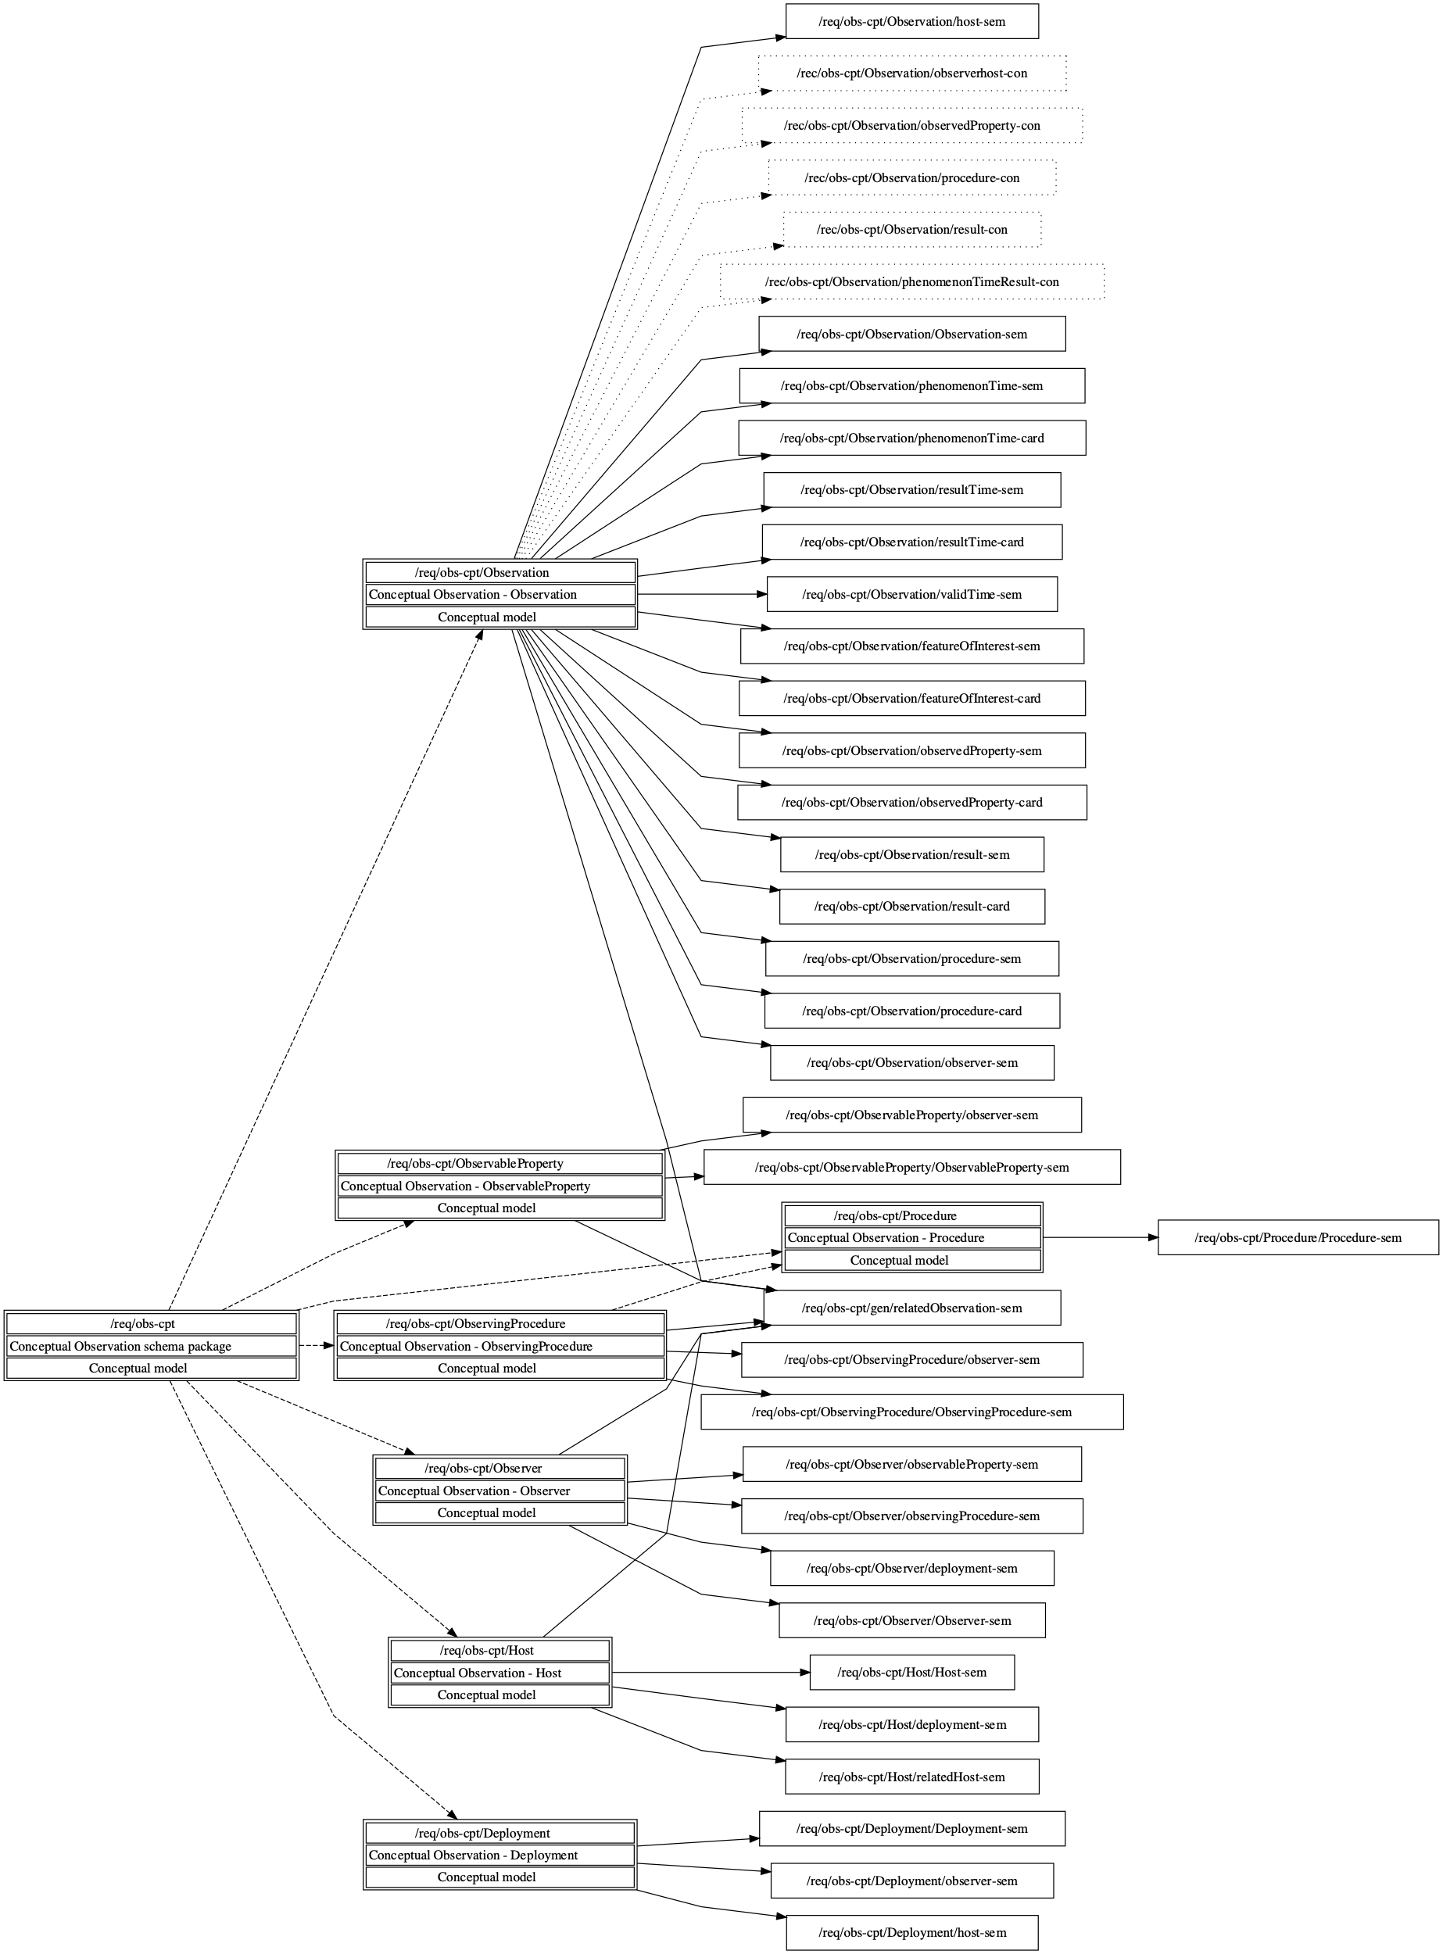

**Figure 8.2 — (Informative) Included direct and indirect requirements and recommendations of the Conceptual Observation schema package requirements class.**

### Association relatedObservation

|  |  |
| --- | --- |
| **Requirement** /req/obs-cpt/gen/relatedObservation-sem | An **Observation** the **Observation** is related to.  If a reference to a related **Observation** is provided, the association with role **relatedObservation** SHALL be used. The **context:GenericName** qualifier of this association may be used to provide further information as to the nature of the relation. |

## Observation

### Observation Requirements Class

|  |  |
| --- | --- |
| **Requirements Class** | /req/obs-cpt/Observation |
| Target type | Conceptual model |
| Name | Conceptual Observation - Observation |
| Dependency | ISO 19103:2015 Geographic information – Conceptual schema language, UML2 conformance class |
| Dependency | ISO 19103:2015 Geographic information – Conceptual schema language, CoreTypes conformance class |
| Dependency | ISO 19108:2002 Geographic information – Temporal schema, Application schemas for data transfer conformance class |
| Requirement | /req/obs-cpt/Observation/Observation-sem |
| Requirement | /req/obs-cpt/Observation/phenomenonTime-sem |
| Requirement | /req/obs-cpt/Observation/phenomenonTime-card |
| Requirement | /req/obs-cpt/Observation/resultTime-sem |
| Requirement | /req/obs-cpt/Observation/resultTime-card |
| Requirement | /req/obs-cpt/Observation/validTime-sem |
| Requirement | /req/obs-cpt/Observation/featureOfInterest-sem |
| Requirement | /req/obs-cpt/Observation/featureOfInterest-card |
| Requirement | /req/obs-cpt/Observation/observedProperty-sem |
| Requirement | /req/obs-cpt/Observation/observedProperty-card |
| Requirement | /req/obs-cpt/Observation/result-sem |
| Requirement | /req/obs-cpt/Observation/result-card |
| Requirement | /req/obs-cpt/Observation/procedure-sem |
| Requirement | /req/obs-cpt/Observation/procedure-card |
| Requirement | /req/obs-cpt/Observation/observer-sem |
| Requirement | /req/obs-cpt/Observation/host-sem |
| Recommendation | /rec/obs-cpt/Observation/observerhost-con |
| Recommendation | /rec/obs-cpt/Observation/observedProperty-con |
| Recommendation | /rec/obs-cpt/Observation/procedure-con |
| Recommendation | /rec/obs-cpt/Observation/result-con |
| Recommendation | /rec/obs-cpt/Observation/phenomenonTimeResult-con |
| Requirement | /req/obs-cpt/gen/relatedObservation-sem |

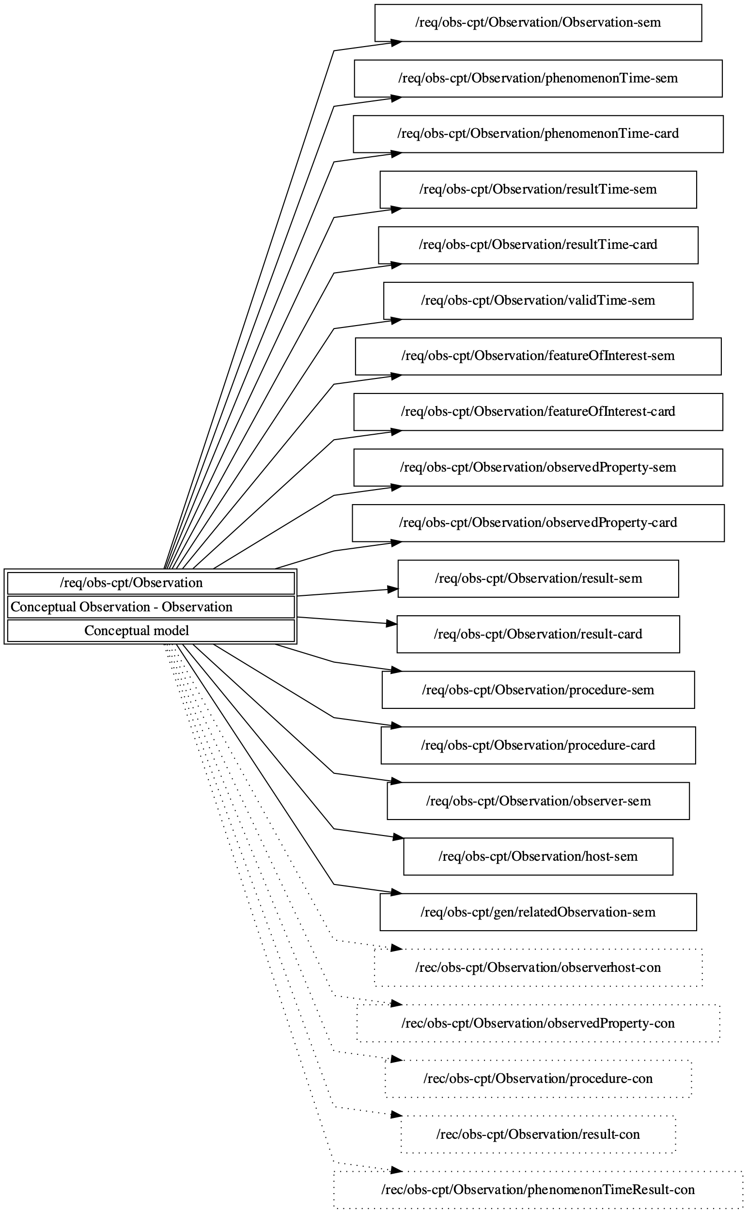

**Figure 8.3— (Informative) Included requirements and recommendations of the Conceptual Observation — Observation requirements class.**

### Interface Observation

|  |  |
| --- | --- |
| **Requirement** /req/obs-cpt/Observation/Observation-sem | An observation is an act carried out by an **Observer** to determine the value of an **ObservableProperty** of an object (**featureOfInterest)** by using a **Procedure**; the value is provided as the **result**. |

NOTE It is important to note that the terms ‘observation’, ‘interpretation’, ‘forecast’, ‘simulation’ do correspond to this definition. This aspect is further clarified in section XXX.

### Attribute phenomenonTime

|  |  |
| --- | --- |
| **Requirement** /req/obs-cpt/Observation/phenomenonTime-sem | The time that the **Result** applies to the **FeatureOfInterest.**  If the **phenomenonTime** is described, this SHALL be provided by the attribute **phenomenonTime:TM\_Object** |

NOTE 1 The phenomenonTime is often the time the Sample has been taken.

NOTE 2 This is often the time of interaction by a sampling Procedure or observation Procedure with a real-world feature.

NOTE 3 If the result is the average of multiple samples taken at different times, then the phenomenonTime is the time interval over which these measurements were taken.

|  |  |
| --- | --- |
| **Requirement** /req/obs-cpt/Observation/phenomenonTime-card | An **Observation** SHALL have exactly 1 **phenomenonTime.** |

|  |  |
| --- | --- |
| **Recommendation** /rec/obs-cpt/Observation/phenomenonTimeResult-con | If the **observedProperty** of an **Observation** is ‘occurrence time’ then the **result** SHOULD be the same as the **phenomenonTime.** |

### Attribute resultTime

|  |  |
| --- | --- |
| **Requirement** /req/obs-cpt/Observation/resultTime-sem | The instant of time when the **result** of the **Observation** became available.  If the **resultTime** is described, this SHALL be provided by the attribute **resultTime:TM\_Object** |

EXAMPLE 1 The resultTime typically corresponds to when the Procedure associated with the Observation was completed. For some observations this is identical to the phenomenonTime. However, there are important cases where they differ.

EXAMPLE 2 Where a measurement is made on a specimen in a laboratory, the phenomenonTime is the time the specimen was retrieved from its host, while the resultTime is the time the laboratory procedure was applied.

EXAMPLE 3 The resultTime also supports disambiguation of repeat measurements made of the same property of a feature using the same procedure.

EXAMPLE 4 Where sensor observation results are post-processed, the resultTime is the post-processing time, while the phenomenonTime is the time of initial interaction with the world.

EXAMPLE 5 Simulations may be used to estimate the values for phenomena in the future or past. The phenomenonTime is the time that the result applies to, while the resultTime is the time that the simulation was executed.

|  |  |
| --- | --- |
| **Requirement** /req/obs-cpt/Observation/resultTime-card | An **Observation** SHALL have exactly 1 **resultTime**. |

### Attribute validTime

|  |  |
| --- | --- |
| **Requirement** /req/obs-cpt/Observation/validTime-sem | The time period during which the **result** is valid.  If **validTime(s)** are described they SHALL be provided by the attribute **validTime:TM\_Object** |

NOTE This attribute is commonly required in forecasting applications.

### Association featureOfInterest

|  |  |
| --- | --- |
| **Requirement** /req/obs-cpt/Observation/featureOfInterest-sem | The subject of the **Observation**.  The reference(s) to **featureOfInterest(s)** SHALL be provided using the association **Domain** with the role **featureOfInterest**. |

NOTE 1 The featureOfInterest can be of Any type

EXAMPLE 1 An instance of a feature modelled in a specific domain model (Borehole according to OGC GeoSciML)

EXAMPLE 2 The bubble of air around the intake of an air quality monitoring station

EXAMPLE 3 An existing well being used for water quality measurements

NOTE 2 This object is the real-world object whose properties are under observation, or is an object created with the intention to sample the real-world object, as described in the Sampling part of section 7. An observation instance serves as a propertyValueProvider for its feature-of-interest.

|  |  |
| --- | --- |
| **Requirement** /req/obs-cpt/Observation/featureOfInterest-card | An **Observation** SHALL have at least 1 **featureOfInterest** and MAY have more than 1 in cases objects are created with the intention to sample the real-world object  The cardinality of the **featureOfInterest** association SHALL be 1 at minimum. |

### Association observedProperty

|  |  |
| --- | --- |
| **Requirement** /req/obs-cpt/Observation/observedProperty-sem | The **ObservableProperty** that is the subject of the **Observation**.  If a reference to an **ObservableProperty** is provided, the association with the role **observedProperty** SHALL be used. |

|  |  |
| --- | --- |
| **Requirement** /req/obs-cpt/Observation/observedProperty-card | An **Observation** SHALL have exactly 1 **observedProperty**. |

### Association result

|  |  |
| --- | --- |
| **Requirement** /req/obs-cpt/Observation/result-sem | The **Result** of the **Observation**.  If a reference to a **result** is provided, the association **Range** with the role **result** SHALL be used. |

NOTE 1 The result can be of Any type as it may represent the value of any feature property.

NOTE 2 If the observed property is a spatial operation or function, the type of the result may be a coverage.

NOTE 3 In some contexts, particularly in earth and environmental sciences, the term “observation” is used to refer to the result itself.

|  |  |
| --- | --- |
| **Requirement** /req/obs-cpt/Observation/result-card | An **Observation** SHALL have exactly 1 **result** . |

### Association procedure

|  |  |
| --- | --- |
| **Requirement** /req/obs-cpt/Observation/procedure-sem | The **ObservingProcedure** used by the **Observation** to determine the value of the **ObservableProperty** provided by the **Result.**  If a reference to an **ObservingProcedure** is provided, the association with the role **procedure** SHALL be used. |

EXAMPLE Observed radiance wavelength is determined by the response characteristics of the sensor.

A description of the observation procedure provides or implies an indication of the reliability or quality of the observation result.

### Association observer

|  |  |
| --- | --- |
| **Requirement** /req/obs-cpt/Observation/observer-sem | An **Observer (ref)** that is involved in the creation of this **Observation**.  If a reference to an **Observer** is provided, the association with the role **observer** SHALL be used. |

### Association host

|  |  |
| --- | --- |
| **Requirement** /req/obs-cpt/Observation/host-sem | A **Host** that is involved in the creation of this **Observation**  If a reference to a **Host** is provided, the association with the role **host** SHALL be used. |

### Constraint Observer or Host

|  |  |
| --- | --- |
| **Recommendation** /rec/obs-cpt/Observation/observerhost-con | At least one **Observer** or **Host** SHOULD be provided |

### Constraint ObservableProperty phenomenon associated with featureOfInterest

|  |  |
| --- | --- |
| **Recommendation** /rec/obs-cpt/Observation/observedProperty-con | The **ObservableProperty** referenced by **observedProperty** SHOULD correspond to a characteristic or phenomenon associated with the **featureOfInterest** |

### Constraint suitable ObservableProperty

|  |  |
| --- | --- |
| **Recommendation** /rec/obs-cpt/Observation/procedure-con | The **ObservingProcedure** referenced by **procedure** SHOULD be suitable for the associated **ObservableProperty** |

### Constraint suitable result type

|  |  |
| --- | --- |
| **Recommendation** /rec/obs-cpt/Observation/result-con | The type of the result provided by the **result** association SHOULD be suitable for the associated **ObservableProperty** |

## ObservableProperty

### ObservableProperty Requirements Class

|  |  |
| --- | --- |
| **Requirements Class** | /req/obs-cpt/ObservableProperty |
| Target type | Conceptual model |
| Name | Conceptual Observation - ObservableProperty |
| Dependency | ISO 19103:2015 Geographic information – Conceptual schema language, UML2 conformance class |
| Requirement | /req/obs-cpt/ObservableProperty/ObservableProperty-sem |
| Requirement | /req/obs-cpt/ObservableProperty/observer-sem |
| Requirement | /req/obs-cpt/gen/relatedObservation-sem |

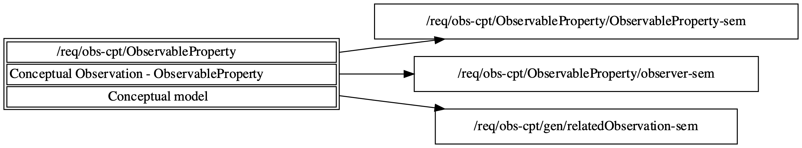

**Figure 8.4— (Informative) Included requirements and recommendations of the Conceptual Observation — ObservableProperty requirements class.**

### Interface ObservableProperty

|  |  |
| --- | --- |
| **Requirement** /req/obs-cpt/ObservableProperty/ObservableProperty-sem | an observable quality (property, characteristic) of the **feature of interest** that may be observed. |

EXAMPLE 1 The height of a tree, the depth of a water body, or the temperature of a surface are examples of observable properties, while the value of a classic car is not (directly) observable but asserted.

EXAMPLE 2 Groundwater Level

On a groundwater well we

* monitor Groundwater Level (1 observable property)
* with an automated probe (that remains in the ground all year, constituting 1 procedure).

Then we have physical campaigns where we revisit the groundwater well and

* measure the Groundwater Level (still the same observable property as above)
* but with a manual probe, this is a different procedure.

This allows to check whether the probe needs recalibration.

### Association observer

|  |  |
| --- | --- |
| **Requirement** /req/obs-cpt/ObservableProperty/observer-sem | An **Observer** capable of observing this **ObservableProperty**.  If a reference to the **Observer** is provided, the association with the role **observer** SHALL be used. |

## Procedure

### Procedure Requirements Class

|  |  |
| --- | --- |
| **Requirements Class** | /req/obs-cpt/Procedure |
| Target type | Conceptual model |
| Name | Conceptual Observation - Procedure |
| Dependency | ISO 19103:2015 Geographic information – Conceptual schema language, UML2 conformance class |
| Requirement | /req/obs-cpt/Procedure/Procedure-sem |

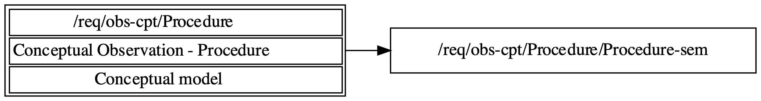

**Figure 8.5— (Informative) Included requirements and recommendations of the Conceptual Observation — Procedure requirements class.**

### Interface Procedure

|  |  |
| --- | --- |
| **Requirement** /req/obs-cpt/Procedure/Procedure-sem | A description of steps performed. |

NOTE Procedure is an abstract concept that is then further specialized in the various procedure types defined in this document. All share the commonality of describing a defined series of steps to a specific purpose.

The term process that was used in ISO 19156:2011 has been purposely dropped in this version to avoid unnecessary confusion between the terms procedure and process.

## ObservingProcedure

### ObservingProcedure Requirements Class

|  |  |
| --- | --- |
| **Requirements Class** | /req/obs-cpt/ObservingProcedure |
| Target type | Conceptual model |
| Name | Conceptual Observation - ObservingProcedure |
| Dependency | ISO 19103:2015 Geographic information – Conceptual schema language, UML2 conformance class |
| Imports | /req/obs-cpt/Procedure |
| Requirement | /req/obs-cpt/ObservingProcedure/ObservingProcedure-sem |
| Requirement | /req/obs-cpt/ObservingProcedure/observer-sem |
| Requirement | /req/obs-cpt/gen/relatedObservation-sem |

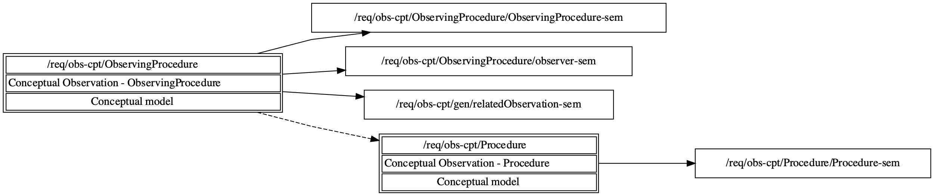

**Figure 8.6— (Informative) Included requirements and recommendations of the Conceptual Observation — ObservingProcedure requirements class.**

### Interface ObservingProcedure

|  |  |
| --- | --- |
| **Requirement** /req/obs-cpt/ObservingProcedure/ObservingProcedure-sem | the description of steps performed in order to determine the value of an **observableProperty** by an **Observer**. |

NOTES:

* Depending on the complexity of the use case, the procedure will be more or less explicitly described. Especially pertaining to historical data, there may be very little or no information available - this information should also be provided.
* The recipe that the observer (cook) follows to generate the observation.
* The procedure is often referred to as the method.
* Different observers can follow the same (reusable) procedure for the creation of different observations.
* The procedure is a workflow, protocol, plan, algorithm, or computational method specifying how to make an observation.
* the observing procedure cannot describe a sensor instance, but it can describe the sensor type.

NOTE The term process that was used in ISO 19156:2011 has been purposely dropped in this version to avoid unnecessary confusion between the terms procedure and process.

EXAMPLE An instance of Procedure is a description of the process utilized by an observer, this could be a chemical analysis method, a protocol for measuring an object, but could also be a checklist utilized by a human observer during a biodiversity campaign. It could further describe the algorithms behind simulators or models used to generate a result from other inputs.

### Association observer

|  |  |
| --- | --- |
| **Requirement** /req/obs-cpt/ObservingProcedure/observer-sem | An **Observer** capable of performing this **ObservingProcedure**.  If a reference to an **Observer** is provided, the association with the role **observer** SHALL be used. |

## Observer

### Observer Requirements Class

|  |  |
| --- | --- |
| **Requirements Class** | /req/obs-cpt/Observer |
| Target type | Conceptual model |
| Name | Conceptual Observation - Observer |
| Dependency | ISO 19103:2015 Geographic information – Conceptual schema language, UML2 conformance class |
| Requirement | /req/obs-cpt/Observer/Observer-sem |
| Requirement | /req/obs-cpt/Observer/observableProperty-sem |
| Requirement | /req/obs-cpt/Observer/observingProcedure-sem |
| Requirement | /req/obs-cpt/Observer/deployment-sem |
| Requirement | /req/obs-cpt/gen/relatedObservation-sem |

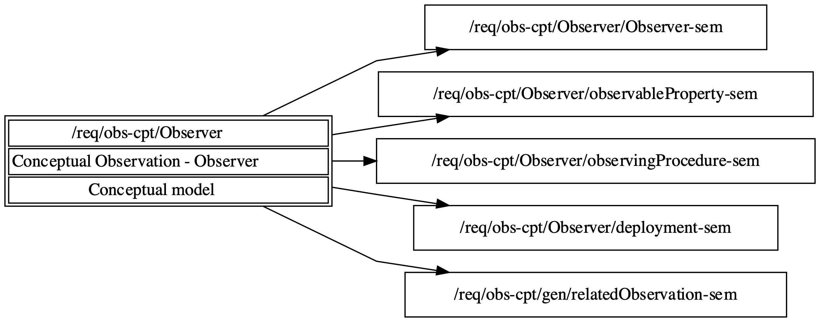

**Figure 8.7— (Informative) Included requirements and recommendations of the Conceptual Observation — Observer requirements class.**

### Interface Observer

|  |  |
| --- | --- |
| **Requirement** /req/obs-cpt/Observer/Observer-sem | An identifiable entity that may generate **Observations** pertaining to an **observableProperty** by implementing a **Procedure**. |

NOTES

* Different Observers can follow the same (reusable) observing Procedure for the creation of different Observations.
* The Observer is the entity instance, not the entity type. Pertaining to sensors, the Observer would reference the explicit sensor, while the Procedure would reference the methodology utilized by that sensor type.
* An Observer is closely linked with an observableProperty that it generates results for.
* An Observer can be hosted by one or more Host.
* The Observer is an instance of a sensor, instrument, implementation of an algorithm or a being such as a person.

An Observer responds to a stimulus, e.g., a change in the environment, or input data composed from the Results of prior Observations, and generates a Result.

EXAMPLE Accelerometers, gyroscopes, barometers, magnetometers, and so forth are Sensors that are typically mounted on a modern smartphone (which acts as Host). Other examples of Sensors include the human eyes.

### Association observableProperty

|  |  |
| --- | --- |
| **Requirement** /req/obs-cpt/Observer/observableProperty-sem | An **ObservableProperty** that this **Observer** can observe.  If a reference to **ObservableProperty**(s)is provided, the association with the role **observableProperty** SHALL be used. |

### Association observingProcedure

|  |  |
| --- | --- |
| **Requirement** /req/obs-cpt/Observer/observingProcedure-sem | An **ObservingProcedure** that this **Observer** can perform.  If a reference to **ObservingProcedure**(s)is provided, the association with the role **observingProcedure** SHALL be used. |

### Association deployment

|  |  |
| --- | --- |
| **Requirement** /req/obs-cpt/Observer/deployment-sem | A **Deployment** to which this **Observer** is either physically or organizationally attached.  If a reference to **Deployment**(s)is provided, the association with the role **deployment** SHALL be used. |

## Host

### Host Requirements Class

|  |  |
| --- | --- |
| **Requirements Class** | /req/obs-cpt/Host |
| Target type | Conceptual model |
| Name | Conceptual Observation - Host |
| Dependency | ISO 19103:2015 Geographic information – Conceptual schema language, UML2 conformance class |
| Requirement | /req/obs-cpt/Host/Host-sem |
| Requirement | /req/obs-cpt/Host/deployment-sem |
| Requirement | /req/obs-cpt/Host/relatedHost-sem |
| Requirement | /req/obs-cpt/gen/relatedObservation-sem |

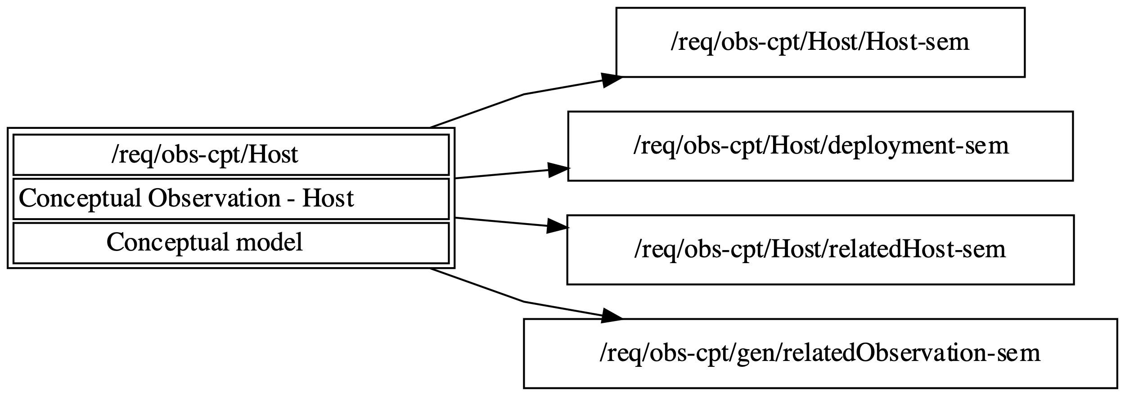

**Figure 8.8— (Informative) Included requirements and recommendations of the Conceptual Observation — Host requirements class.**

### Interface Host

|  |  |
| --- | --- |
| **Requirement** /req/obs-cpt/Host/Host-sem | A grouping of **Observer**s for a specific reason. |

NOTES:

* In many use cases, the Host is the environmental monitoring facility
* The Host can be a platform that hosts a set of sensors
* An alternative usage could pertain to a biodiversity survey campaign; in this scenario, the team performing the survey would be modelled as observers whereas the entire survey campaign can be represented as a Host.

### Association deployment

|  |  |
| --- | --- |
| **Requirement** /req/obs-cpt/Host/deployment-sem | A **Deployment** at this **Host**.  If a reference to a **Deployment** is provided, the association with the role **host** SHALL be used. |

### Association relatedHost

|  |  |
| --- | --- |
| **Requirement** /req/obs-cpt/Host/relatedHost-sem | A **Host** the **Host** is related to.  If a reference to a related **Host** is provided, the association with role **relatedHost** SHALL be used. The **context:GenericName** qualifier of this association may be used to provide further information as to the nature of the relation. |

## Deployment

### Deployment Requirements Class

|  |  |
| --- | --- |
| **Requirements Class** | /req/obs-cpt/Deployment |
| Target type | Conceptual model |
| Name | Conceptual Observation - Deployment |
| Dependency | ISO 19103:2015 Geographic information – Conceptual schema language, UML2 conformance class |
| Requirement | /req/obs-cpt/Deployment/Deployment-sem |
| Requirement | /req/obs-cpt/Deployment/observer-sem |
| Requirement | /req/obs-cpt/Deployment/host-sem |

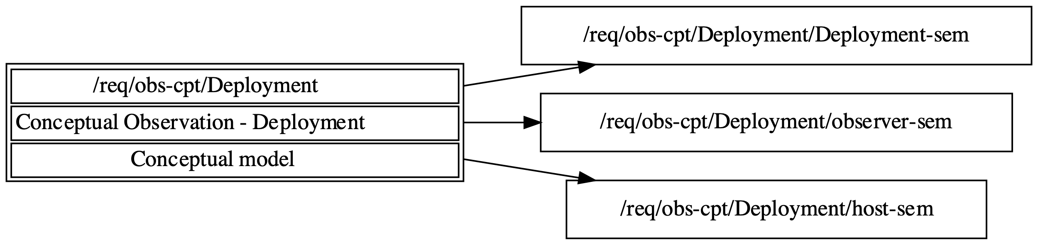

**Figure 8.9— (Informative) Included requirements and recommendations of the Conceptual Observation — Deployment requirements class.**

### Interface Deployment

|  |  |
| --- | --- |
| **Requirement** /req/obs-cpt/Deployment/Deployment-sem | Information on the assignment of an **Observer** to a **Host.** |

NOTE A Deployment can range from

* information regarding a sensor being attached to a pole
* the monitoring facilities pertaining to an environmental monitoring network
* the description of a ship cruise to
* the participation of a citizen in a citizen-science project involving crowd sensing.

### Association observer

|  |  |
| --- | --- |
| **Requirement** /req/obs-cpt/Deployment/observer-sem | The **Observer** associated with this **Deployment**.  If a reference to an **Observer** is provided, the association with the role **observer** SHALL be used. |

### Association host

|  |  |
| --- | --- |
| **Requirement** /req/obs-cpt/Deployment/host-sem | The **Host** to which this **Deployment** pertains.  If a reference to a **Host** is provided, the association with the role **host** SHALL be used |

# Abstract Observation Core

## General

### Abstract Observation Core Package Requirements Class

|  |  |
| --- | --- |
| **Requirements Class** | /req/obs-core |
| Target type | Logical model |
| Name | Abstract Observation core package |
| Dependency | ISO 19103:2015 Geographic information – Conceptual schema language, UML2 conformance class |
| Imports | /req/obs-core/AbstractObservationCharacteristics |
| Imports | /req/obs-core/AbstractObservation |
| Imports | /req/obs-core/AbstractObservableProperty |
| Imports | /req/obs-core/AbstractObservingProcedure |
| Imports | /req/obs-core/AbstractObserver |
| Imports | /req/obs-core/AbstractHost |
| Imports | /req/obs-core/AbstractDeployment |

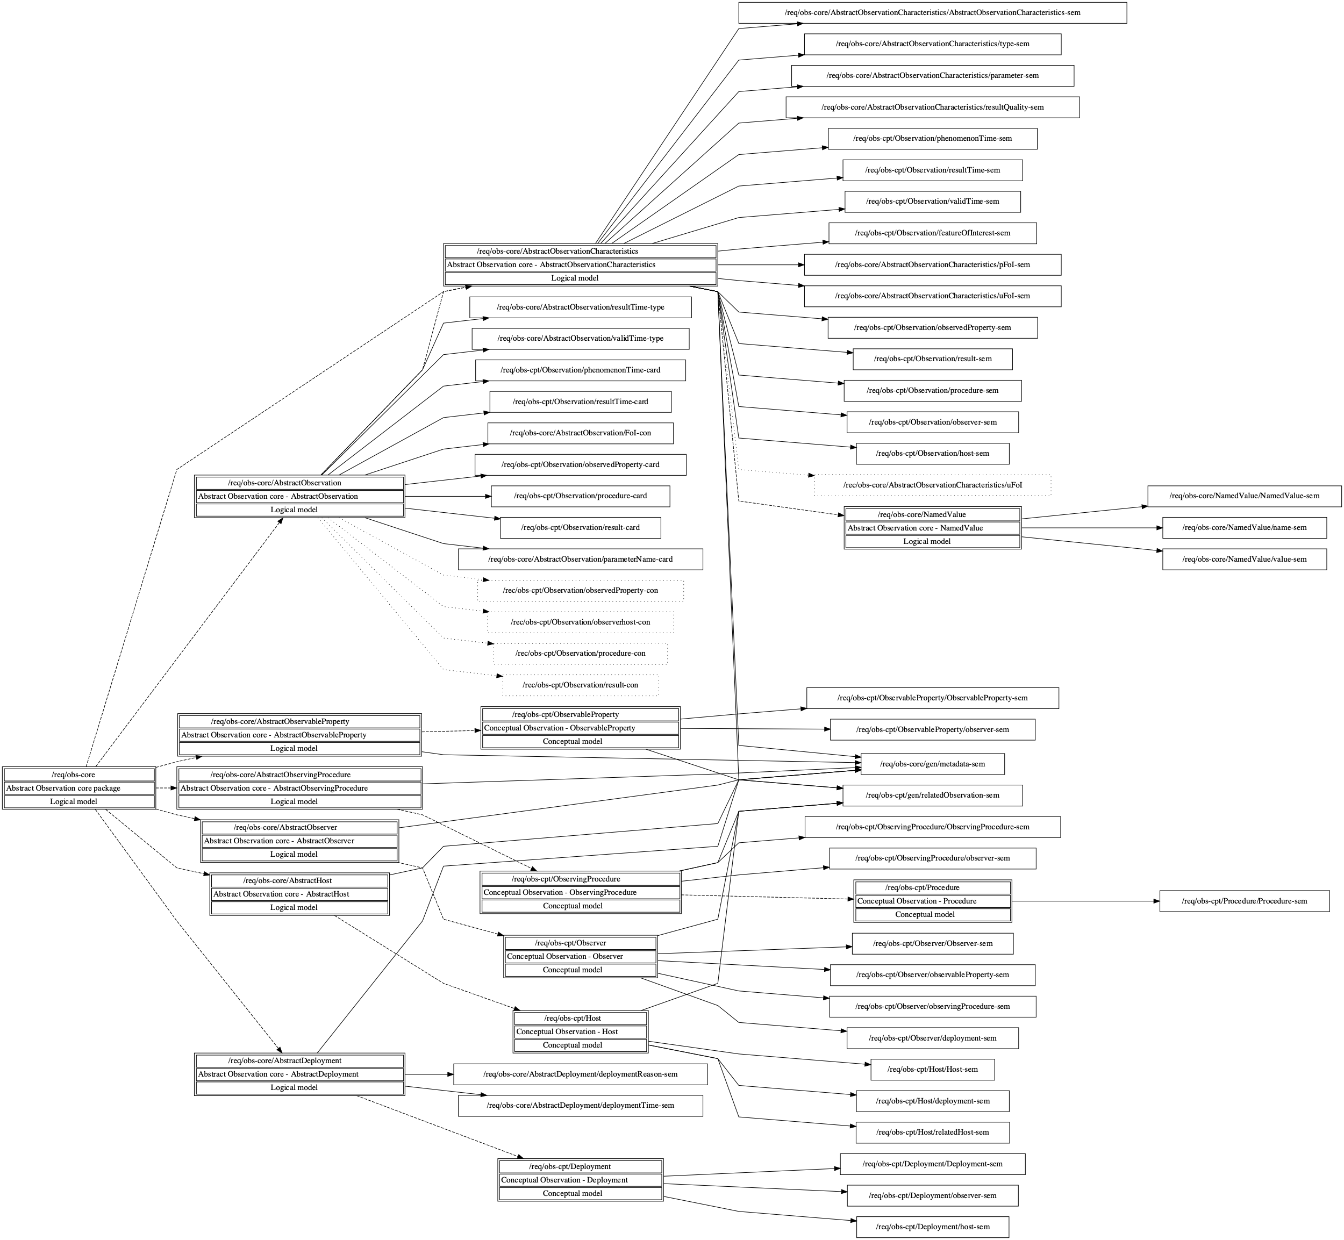

**Figure 9.1— (Informative) Included direct and indirect requirements and recommendations of the Abstract Observation core package requirements class.**

### Association metadata

|  |  |
| --- | --- |
| **Requirement** /req/obs-core/gen/metadata-sem | If descriptive metadata is provided, the association role **metadata** SHALL link to descriptive metadata as commonly understood by communities. |

NOTE Attention should be given not to reinvent semantic that is explicitly modeled in the O&M model.

## AbstractObservationCharacteristics

### AbstractObservationCharacteristics Requirements Class

|  |  |
| --- | --- |
| **Requirements Class** | /req/obs-core/AbstractObservationCharacteristics |
| Target type | Logical model |
| Name | Abstract Observation core - AbstractObservationCharacteristics |
| Dependency | ISO 19103:2015 Geographic information – Conceptual schema language, UML2 conformance class |
| Dependency | ISO 19103:2015 Geographic information – Conceptual schema language, CoreTypes conformance class |
| Dependency | ISO 19108:2002 Geographic information – Temporal schema, Application schemas for data transfer conformance class |
| Requirement | /req/obs-core/AbstractObservationCharacteristics/AbstractObservationCharacteristics-sem |
| Requirement | /req/obs-core/AbstractObservationCharacteristics/type-sem |
| Requirement | /req/obs-core/AbstractObservationCharacteristics/parameter-sem |
| Requirement | /req/obs-core/AbstractObservationCharacteristics/resultQuality-sem |
| Requirement | /req/obs-cpt/Observation/phenomenonTime-sem |
| Requirement | /req/obs-cpt/Observation/resultTime-sem |
| Requirement | /req/obs-cpt/Observation/validTime-sem |
| Requirement | /req/obs-cpt/Observation/featureOfInterest-sem |
| Requirement | /req/obs-core/AbstractObservationCharacteristics/pFoI-sem |
| Requirement | /req/obs-core/AbstractObservationCharacteristics/uFoI-sem |
| Requirement | /req/obs-cpt/Observation/observedProperty-sem |
| Requirement | /req/obs-cpt/Observation/result-sem |
| Requirement | /req/obs-cpt/Observation/procedure-sem |
| Requirement | /req/obs-cpt/Observation/observer-sem |
| Requirement | /req/obs-cpt/Observation/host-sem |
| Requirement | /req/obs-cpt/gen/relatedObservation-sem |
| Requirement | /req/obs-core/gen/metadata-sem |
| Recommendation | /rec/obs-core/AbstractObservationCharacteristics/uFoI |
| Imports | /req/obs-core/NamedValue |

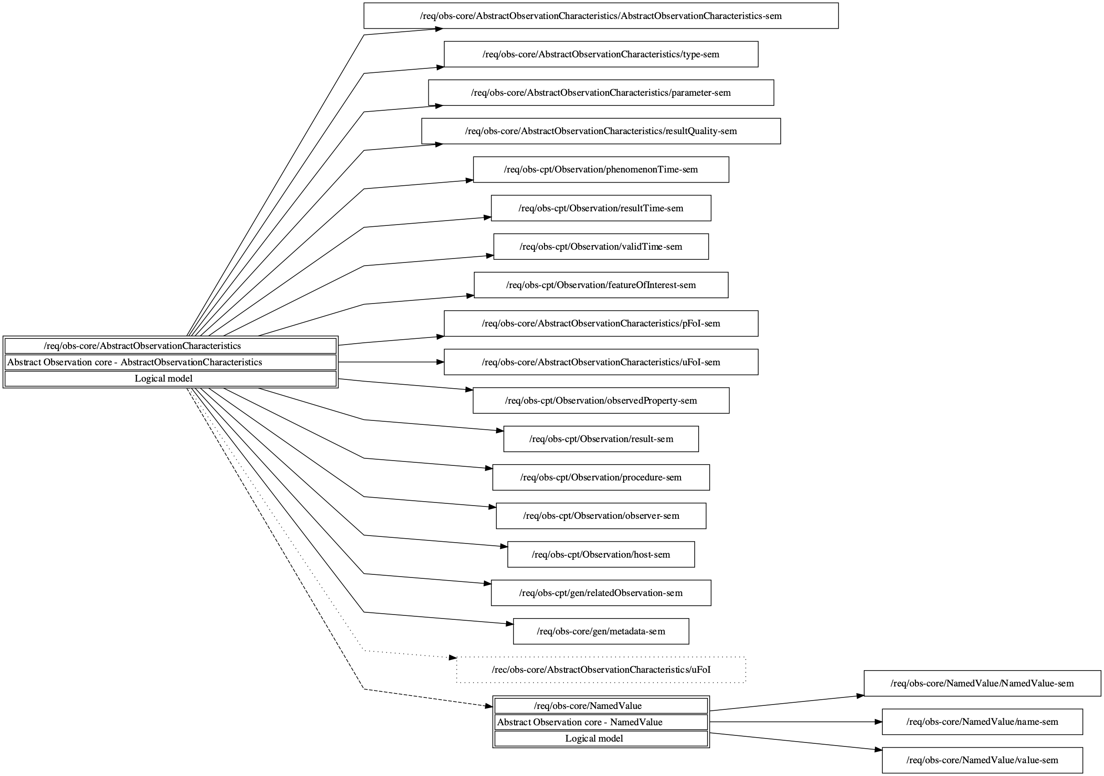

**Figure 9.2— (Informative) Included direct and indirect requirements and recommendations of the AbstractObservationCharacteristics requirements class.**

### Feature type AbstractObservationCharacteristics

|  |  |
| --- | --- |
| **Requirement** /req/obs-core/AbstractObservationCharacteristics/AbstractObservationCharacteristics-sem | Set of common characteristics used for describing an **Observation** or a collection of Observations. |

### Attribute observationType

|  |  |
| --- | --- |
| **Requirement** /req/obs-core/AbstractObservationCharacteristics/type-sem | Information providing further detail on the type of Observations being described by the **AbstractObservationCharacteristics**.  If information on the type of Observation is provided, the property **observationType:AbstractObservationTypeCodeListValue** SHALL be used. |

NOTE Observation type allows describing the formalism, encoding, etc. to be expected when accessing objects associated to the Observation.

NOTE Multiple types may be applied to one Observation, e.g. in the case where the Observation is being typed both by the feature-of-interest geometry as well as Result type.

### Attribute parameter

|  |  |
| --- | --- |
| **Requirement** /req/obs-core/AbstractObservationCharacteristics/parameter-sem | Arbitrary event-specific parameter relevant to the **AbstractObservationCharacteristics**.  If additional parameter information is provided, the property **parameter:NamedValue** SHALL be used. |

NOTE Disambiguation: Parameter should not be used instead of the procedure to describe the steps performed in order to determine the value of the ObservableProperty

NOTE Parameter should NOT be utilized to provide information already contained in the model by existing attributes or associations.

NOTE This might be an environmental parameter, an instrument setting or input, or an event-specific sampling parameter that is not tightly bound to either the feature-of-interest or to the observation procedure. To avoid ambiguity, there shall be no more than one parameter with the same name.

NOTE Parameters that are tightly bound to the procedure can be recorded as part of the procedure description.

The AbstractObservingProcedure is a generic or standard procedure, rather than an event-specific process. In this context, parameters bound to the observation act, such as instrument settings, calibrations or inputs, local position, detection limits, asset identifier, operator, may augment the description of a standard procedure.

EXAMPLE A time sequence of observations of water quality in a well might be made at variable depths within the well. While these can be associated with specimens taken from the well at this depth as the features-of-interest, a more common approach is to identify the well itself as the feature-of-interest, and add a “samplingDepth” parameter to the observation. The sampling depth is of secondary interest compared to the temporal variation of water quality at the site.

### Attribute resultQuality

|  |  |
| --- | --- |
| **Requirement** /req/obs-core/AbstractObservationCharacteristics/resultQuality-sem | Information pertaining to the data quality of the **Result** (**ref**).  If additional data quality information is provided, the property **resultQuality:Any** SHALL be used. |

NOTE This instance-specific description complements the description of the observation Procedure, which provides information concerning the quality of all observations using this procedure. The quality of a result may be assessed following the procedures in ISO 19157. Multiple measures may be provided.

### Association proximateFeatureOfInterest

|  |  |
| --- | --- |
| **Requirement** /req/obs-core/AbstractObservationCharacteristics/pFoI-sem | The entity that is directly of interest in the act of observing.  If a reference to the entity being directly observed is provided, the association with the role **proximateFeatureOfInterest** SHALL be used.  This association is a specialization of the **featureOfInterest** role. |

NOTE The measurement process may be performed on an intermediary entity referred to as proximateFeatureOfInterest that acts as a proxy to the ultimate feature of interest that is being observed (measured, estimated or calculated).

### Association ultimateFeatureOfInterest

|  |  |
| --- | --- |
| **Requirement** /req/obs-core/AbstractObservationCharacteristics/uFoI-sem | The entity that is ultimately of interest in the act of observing.  If a reference to the entity ultimately being observed is provided, the association with the role **ultimateFeatureOfInterest** SHALL be used.  This association is a specialization of the **featureOfInterest** role. |

NOTE The measurement process may be performed on an intermediary entity that acts as a proxy to the ultimate feature of interest that is being observed (measured, estimated or calculated).

If in the real world both ultimateFeatureOfInterest and proximateFeatureOfInterest exist but not both have a digital representation, then the appropriate relation should be selected that best describes the nature of the entity being referenced.

|  |  |
| --- | --- |
| **Recommendation** /rec/obs-core/AbstractObservationCharacteristics/uFoI | In the case where ultimate and proximate features-of-interest are the same object, the association SHOULD be provided using the **ultimateFeatureOfInterest** association role. |

NOTE There will often be a specifiable relationship between the proximate and ultimate feature of interest, such as a sampling-chain, see Clause 7.2.2 for examples.

EXAMPLE a river, an aquifer, soil layer, outcrop, a butterfly, a survey area, a room, Abby's car, a specific human being, this document

EXAMPLE 1: To determine the concentrations of chemical compounds in a river, a sample is taken in a predefined location in the river. This sample is taken to a laboratory where the required chemical analysis is done. In this case, the river is the ultimateFeatureOfInterest, while the sample is the proximateFeatureOfInterest .

EXAMPLE 2: Pertaining to document and observations on the consistency thereof, for the Observation “This clause is inconsistent”, the ultimateFeatureOfInterest is the entire document, while the proximateFeatureOfInterest is the specific clause being addressed.

EXAMPLE 3: the determination of the species of the butterfly, in this case the butterfly is the ultimateFeatureOfInterest, no proximateFeatureOfInterest need be provided.

## AbstractObservation

### AbstractObservation Requirements Class

|  |  |
| --- | --- |
| **Requirements Class** | /req/obs-core/AbstractObservation |
| Target type | Logical model |
| Name | Abstract Observation core - AbstractObservation |
| Dependency | ISO 19103:2015 Geographic information – Conceptual schema language, UML2 conformance class |
| Dependency | ISO 19103:2015 Geographic information – Conceptual schema language, CoreTypes conformance class |
| Dependency | ISO 19108:2002 Geographic information – Temporal schema, Application schemas for data transfer conformance class |
| Imports | /req/obs-core/AbstractObservationCharacteristics |
| Requirement | /req/obs-core/AbstractObservation/resultTime-type |
| Requirement | /req/obs-core/AbstractObservation/validTime-type |
| Requirement | /req/obs-cpt/Observation/phenomenonTime-card |
| Requirement | /req/obs-cpt/Observation/resultTime-card |
| Requirement | /req/obs-core/AbstractObservation/FoI-con |
| Requirement | /req/obs-cpt/Observation/observedProperty-card |
| Requirement | /req/obs-cpt/Observation/procedure-card |
| Requirement | /req/obs-cpt/Observation/result-card |
| Recommendation | /rec/obs-cpt/Observation/observedProperty-con |
| Recommendation | /rec/obs-cpt/Observation/observerhost-con |
| Recommendation | /rec/obs-cpt/Observation/procedure-con |
| Recommendation | /rec/obs-cpt/Observation/result-con |
| Requirement | /req/obs-core/AbstractObservation/parameterName-card |

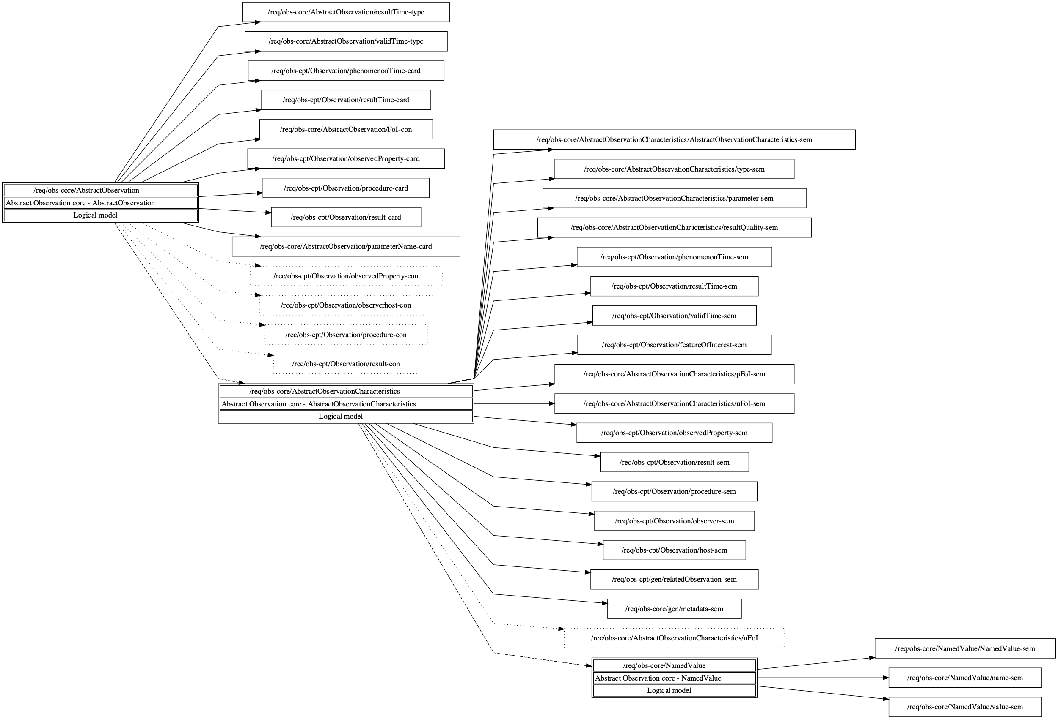

**Figure 9.3— (Informative) Included direct and indirect requirements and recommendations of the AbstractObservation requirements class.**

### Constraint resultTime instant

|  |  |
| --- | --- |
| **Requirement** /req/obs-core/AbstractObservation/resultTime-type | If the result time of the **Observation** is provided, the **resultTime** attribute SHALL be of type **TM\_Instant**. |

### Constraint validTime period

|  |  |
| --- | --- |
| **Requirement** /req/obs-core/AbstractObservation/validTime-type | If the result time of the **Observation** is provided, the **validTime** attribute SHALL be of type **TM\_Period**. |

### Constraint parameter unique name

|  |  |
| --- | --- |
| **Requirement** /req/obs-core/AbstractObservation/parameterName-card | The **name** attribute of a **parameter NamedValue** SHALL be unique within an **Observation**. |

### Constraint proximate or ultimate featureOfInterest

|  |  |
| --- | --- |
| **Requirement** /req/obs-core/AbstractObservation/FoI-con | at least one **proximateFeatureOfInterest** or **ultimateFeatureOfInterest** SHALL be given. |

## AbstractObservableProperty

### AbstractObservableProperty Requirements Class

|  |  |
| --- | --- |
| **Requirements Class** | /req/obs-core/AbstractObservableProperty |
| Target type | Logical model |
| Name | Abstract Observation core - AbstractObservableProperty |
| Dependency | ISO 19103:2015 Geographic information – Conceptual schema language, UML2 conformance class |
| Imports | /req/obs-cpt/ObservableProperty |
| Requirement | /req/obs-core/gen/metadata-sem |

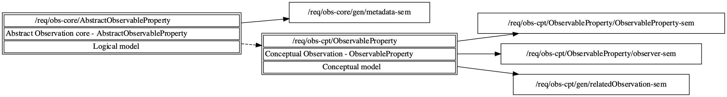

**Figure 9.4— (Informative) Included direct and indirect requirements and recommendations of the AbstractObservableProperty requirements class.**

**Figure 9.5 — Context diagram for AbstractObservableProperty.**

## AbstractObservingProcedure

### AbstractObservingProcedure Requirements Class

|  |  |
| --- | --- |
| **Requirements Class** | /req/obs-core/AbstractObservingProcedure |
| Target type | Logical model |
| Name | Abstract Observation core - AbstractObservingProcedure |
| Dependency | ISO 19103:2015 Geographic information – Conceptual schema language, UML2 conformance class |
| Imports | /req/obs-cpt/ObservingProcedure |
| Requirement | /req/obs-core/gen/metadata-sem |

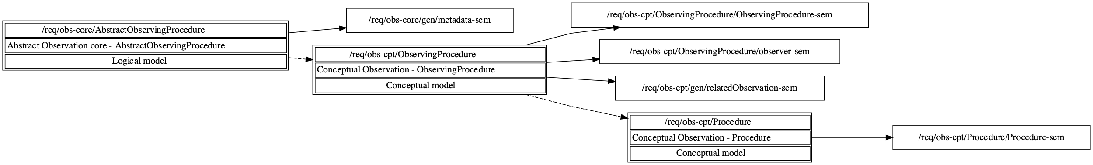

**Figure 9.6— (Informative) Included direct and indirect requirements and recommendations of the AbstractObservingProcedure requirements class.**

**Figure 9.7 — Context diagram for AbstractObservingProcedure.**

## AbstractObserver

### AbstractObserver Requirements Class

|  |  |
| --- | --- |
| **Requirements Class** | /req/obs-core/AbstractObserver |
| Target type | Logical model |
| Name | Abstract Observation core - AbstractObserver |
| Dependency | ISO 19103:2015 Geographic information – Conceptual schema language, UML2 conformance class |
| Imports | /req/obs-cpt/Observer |
| Requirement | /req/obs-core/gen/metadata-sem |

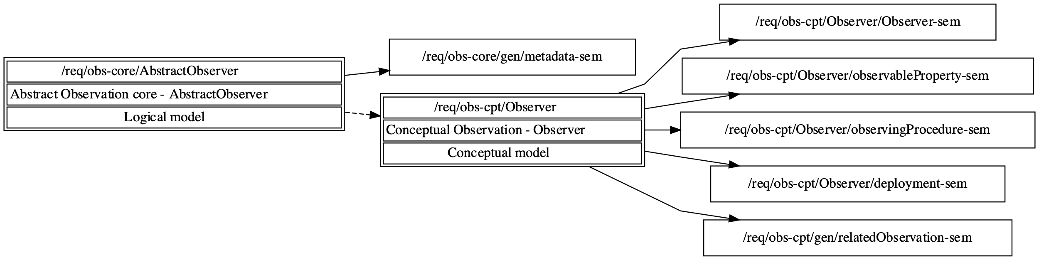

**Figure 9.8— (Informative) Included direct and indirect requirements and recommendations of the AbstractObserver requirements class.**

**Figure 9.9 — Context diagram for AbstractObserver, AbstractHost and AbstractDeployment.**

## AbstractHost

### AbstractHost Requirements Class

|  |  |
| --- | --- |
| **Requirements Class** | /req/obs-core/AbstractHost |
| Target type | Logical model |
| Name | Abstract Observation core - AbstractHost |
| Dependency | ISO 19103:2015 Geographic information – Conceptual schema language, UML2 conformance class |
| Imports | /req/obs-cpt/Host |
| Requirement | /req/obs-core/gen/metadata-sem |

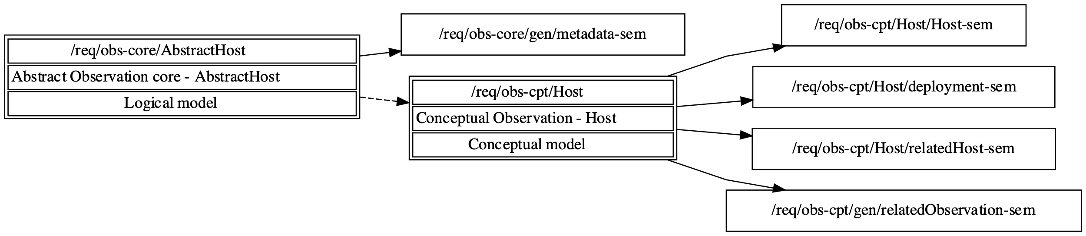

**Figure 9.10— (Informative) Included direct and indirect requirements and recommendations of the AbstractHost requirements class.**

**Figure 9.11 — Context diagram for AbstractHost.**

## AbstractDeployment

### AbstractDeployment Requirements Class

|  |  |
| --- | --- |
| **Requirements Class** | /req/obs-core/AbstractDeployment |
| Target type | Logical model |
| Name | Abstract Observation core - AbstractDeployment |
| Dependency | ISO 19103:2015 Geographic information – Conceptual schema language, UML2 conformance class |
| Dependency | ISO 19103:2015 Geographic information – Conceptual schema language, CoreTypes conformance class |
| Dependency | ISO 19108:2002 Geographic information – Temporal schema, Application schemas for data transfer conformance class |
| Imports | /req/obs-cpt/Deployment |
| Requirement | /req/obs-core/AbstractDeployment/deploymentReason-sem |
| Requirement | /req/obs-core/AbstractDeployment/deploymentTime-sem |
| Requirement | /req/obs-core/gen/metadata-sem |

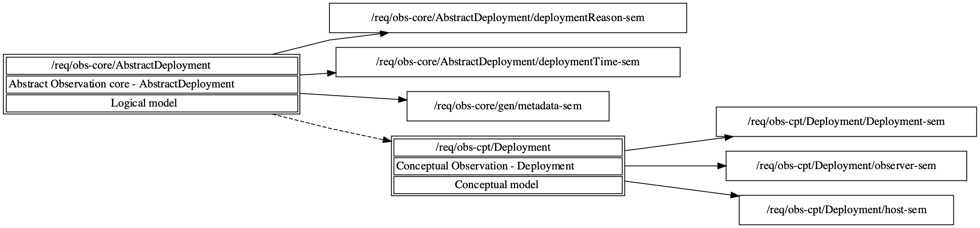

**Figure 9.12— (Informative) Included direct and indirect requirements and recommendations of the AbstractDeployment requirements class.**

### Attribute deploymentReason

|  |  |
| --- | --- |
| **Requirement** /req/obs-core/AbstractDeployment/deploymentReason-sem | A human readable description of the reason for the **Deployment**.  If the reason for the **Deployment** is provided, the property ***deploymentReason:CharacterString***SHALL be used. |

EXAMPLES

* A researcher involved in a biodiversity survey campaign assessing the distribution of selected alien species. The deploymentReason describes the fact that this individual was involved in this campaign for the reason of identifying alien species.
* A sensor is mounted on a building to monitor seismic activities
* A new sensor type is rolled out within a regional or thematic network due to new legal reporting requirements.

### Attribute deploymentTime

|  |  |
| --- | --- |
| **Requirement** /req/obs-core/AbstractDeployment/deploymentTime-sem | The time that the **Deployment** pertains to.  If the time of the **Deployment** is provided, property ***deploymentTime:TM\_Period***SHALL be used. |

EXAMPLES

* A researcher involved in a biodiversity survey campaign assessing the distribution of selected alien species. The deploymentTime provides the time period(s) during which this person carried out this activity in the framework of the campaign.
* A sensor is mounted on a building to monitor seismic activities. The deploymentTime provides the time period(s) during which this sensor is mounted or active.

## NamedValue

### NamedValue Requirements Class

|  |  |
| --- | --- |
| **Requirements Class** | /req/obs-core/NamedValue |
| Target type | Logical model |
| Name | Abstract Observation core - NamedValue |
| Dependency | ISO 19103:2015 Geographic information – Conceptual schema language, UML2 conformance class |
| Dependency | ISO 19103:2015 Geographic information – Conceptual schema language, CoreTypes conformance class |
| Requirement | /req/obs-core/NamedValue/NamedValue-sem |
| Requirement | /req/obs-core/NamedValue/name-sem |
| Requirement | /req/obs-core/NamedValue/value-sem |

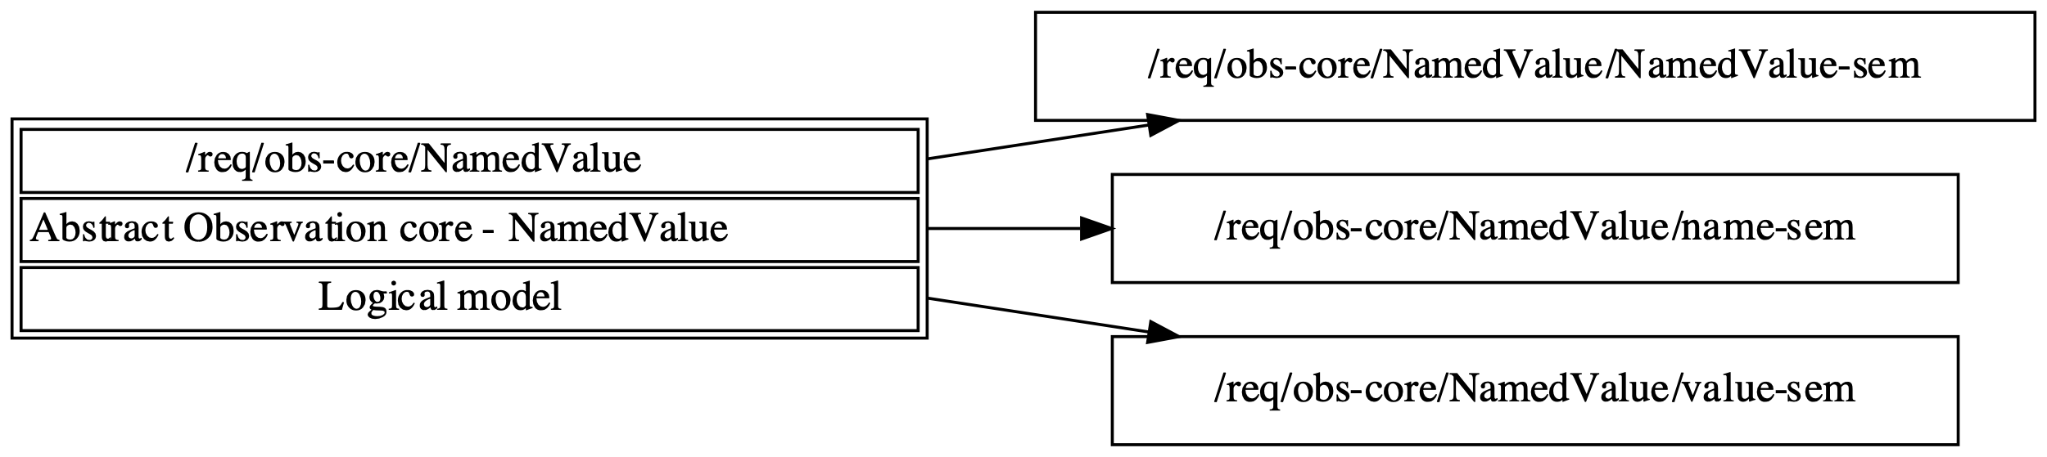

**Figure 9.13— (Informative) Included direct and indirect requirements and recommendations of the NamedValue requirements class.**

### Data type NamedValue

|  |  |
| --- | --- |
| **Requirement** /req/obs-core/NamedValue/NamedValue-sem | The class **NamedValue** provides for a generic soft-typed parameter value. |

### Attribute name

|  |  |
| --- | --- |
| **Requirement** /req/obs-core/NamedValue/name-sem | The attribute **name:GenericName** SHALL indicate the meaning of the named value. |

NOTE The value of the name should be taken from a well-governed source if possible.

EXAMPLE When used as the value of an Observation:parameter, the name might take values like ‘procedureOperator’, ‘detectionLimit’, ‘amplifierGain’, ‘samplingDepth’, 'analysisIteration', ...

### Attribute value

|  |  |
| --- | --- |
| **Requirement** /req/obs-core/NamedValue/value-sem | The attribute **value:Any** SHALL provide the value. |

NOTE The type “Any” should be substituted by a suitable concrete type, such as CI\_ResponsibleParty or Measure.

# Basic Observations

# Conceptual Sample schema

# Abstract Sample Core

# Basic Samples

1. (normative)  
     
   Abstract test suite
   1. Clause title autonumber

*Use subclauses if required e.g. A.1.1 or A.1.1.1. For example:*

* + 1. Subclause autonumber
       1. Subclause autonumber

Type text.

Dimensions in millimetres

figure_exemple

**Key**

|  |  |  |  |
| --- | --- | --- | --- |
| 1 | desiccant/aqueous saturated salt solution |  |  |
| 2 | test specimen |  |  |
| 3 | sealant |  |  |
| 4 | template |  |  |

NOTE Figure note.

|  |  |
| --- | --- |
| a | It is the upper exposed area. |
| b | It is the lower exposed area. |

**Figure A.1 — Example**

**Table A.1 — Example**

|  |  |  |  |  |
| --- | --- | --- | --- | --- |
| **Type** a | **No. series** | **Pressure** | **Length** | **Temperature** |
| *p*1 | *l*2 | *T*1 |
| MPa | mm | °C |
| A | 248-i | 50 | 216 | 50 |
| B | 556-i | 100 b | 287 | 60,5 |
| C | 43-ii | 200 | 300 | 38 |
| NOTE   Table note.  a   Table footnote.  b   Second table footnote. | | | | |

1. (informative)  
     
   Common usage of O&M terminology
   1. Clause title autonumber

*Use subclauses if required e.g. A.1.1 or A.1.1.1. For example:*

* + 1. Subclause autonumber
       1. Subclause autonumber

Type text.

1. (informative)  
     
   Alignment with ISO 19156:2011
   1. Clause title autonumber

*Use subclauses if required e.g. A.1.1 or A.1.1.1. For example:*

* + 1. Subclause autonumber
       1. Subclause autonumber

Type text.

1. (informative)  
     
   Best practices in use of the Observation and Sampling models
   1. Clause title autonumber

*Use subclauses if required e.g. A.1.1 or A.1.1.1. For example:*

* + 1. Subclause autonumber
       1. Subclause autonumber

Type text.

Bibliography

[1] ISO #####‑#, *General title — Part #: Title of part*

[2] ISO #####‑##:20##, *General title — Part ##: Title of part*

1. To be published. [↑](#footnote-ref-1)